## Arduino UNO R4 Wi-Fi All-in-one IoT center

Difficult Level: 

## Arduino UNO R4 Wi-Fi Part

In this chapter, you can follow one of our practical tutorials to complete the construction of a smart home. It includes data collection and reporting of temperature, humidity and air pressure sensors, as well as methods for modifying Home Assistant's configuration files.

### Preparations

* 1 x Temperature & Humidity sensor
* 1 x BMP280 Air pressure sensor
* 1 x Breadboard
* 1 x Arduino UNO R4 Wi-Fi board
* 1 x USB-C programming cable
* 1 x Home assistant server
* 10 x Male to Male Dupong Wire (Jumper wire)

### Software Preparations

* Arduino IDE 2.0 or later
* Libraries required:　ArduinoMqttClient, Adafruit BMP280 Library, DHT11

#### Install libraries

For example, Install libraries “ArduinoMqttClient” in Arduino IDE, click the libraries icon and input “arduinoMqttClient” in search bar:

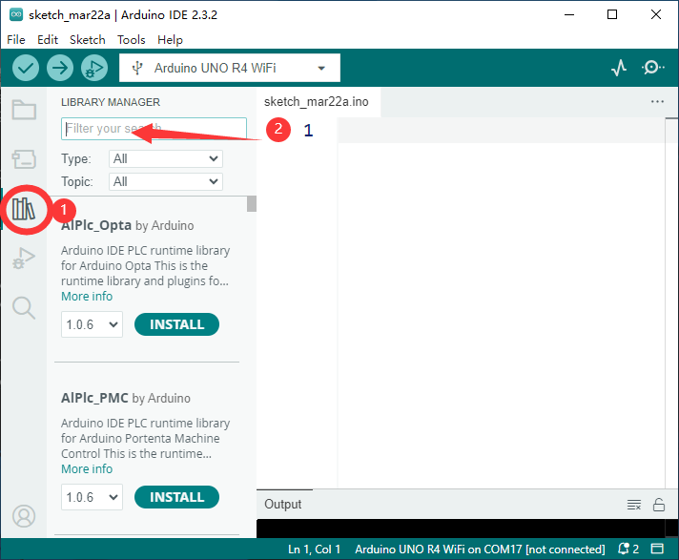

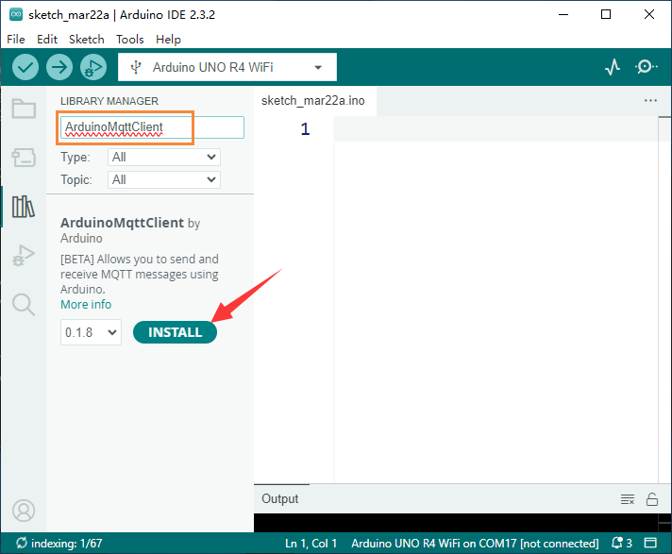

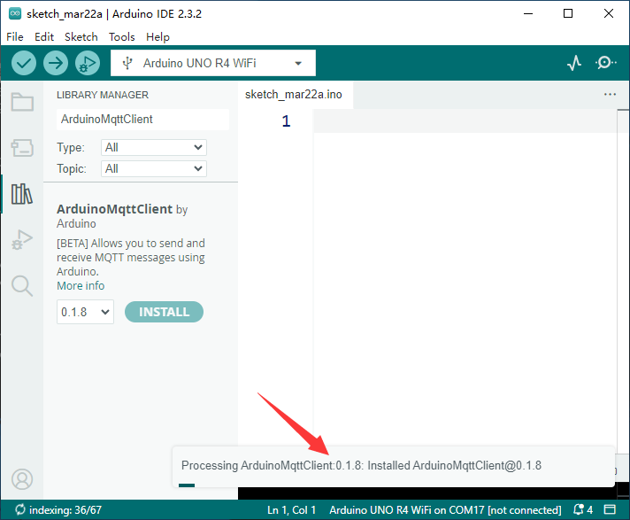

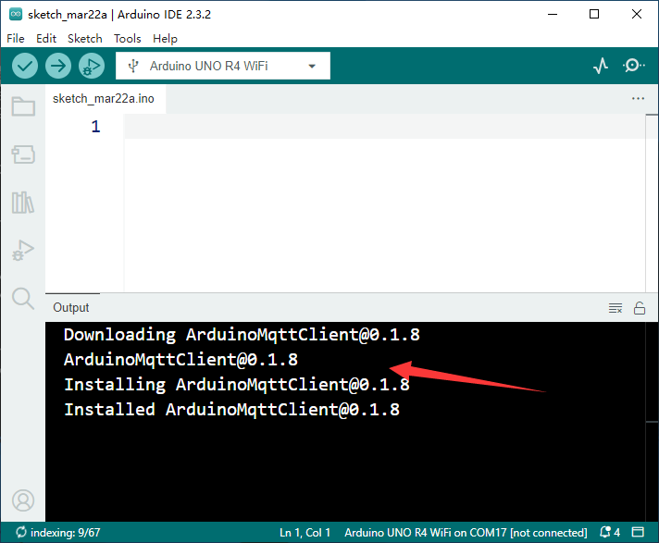or you can download the zip file directly from this URL: <https://github.com/arduino-libraries/ArduinoMqttClient> and then unzip it to the Arduino IDE installation location’s libraries fold.

NOTE: Please use similar methods to install other libraries.

#### Wiring Diagram

For the wiring method, please refer to the wiring method of the temperature and humidity sensor and BMP280 in Chapter 4. Following chart shows the connection between arduino UNO R4 and sensors

|  |  |
| --- | --- |
| Arduino UNO R4 Wi-Fi board | Temperature & Humidity sensor (DHT11) |
| 5V | VCC |
| Pin 7 | DATA |
| GND | GND |

|  |  |
| --- | --- |
| Arduino UNO R4 Wi-Fi board | Air Pressure sensor (BMP280) |
| 3.3V | VCC |
| A4 | SDA |
| A5 | SCL |
| GND | GND |

|  |  |
| --- | --- |
| Arduino UNO R4 Wi-Fi board | Buzzer |
| Pin 9 | + Positive Polar |
| GND | GND |

### Demo code

you can also modify the official demo which you can find on Arduino IDE’s examples.

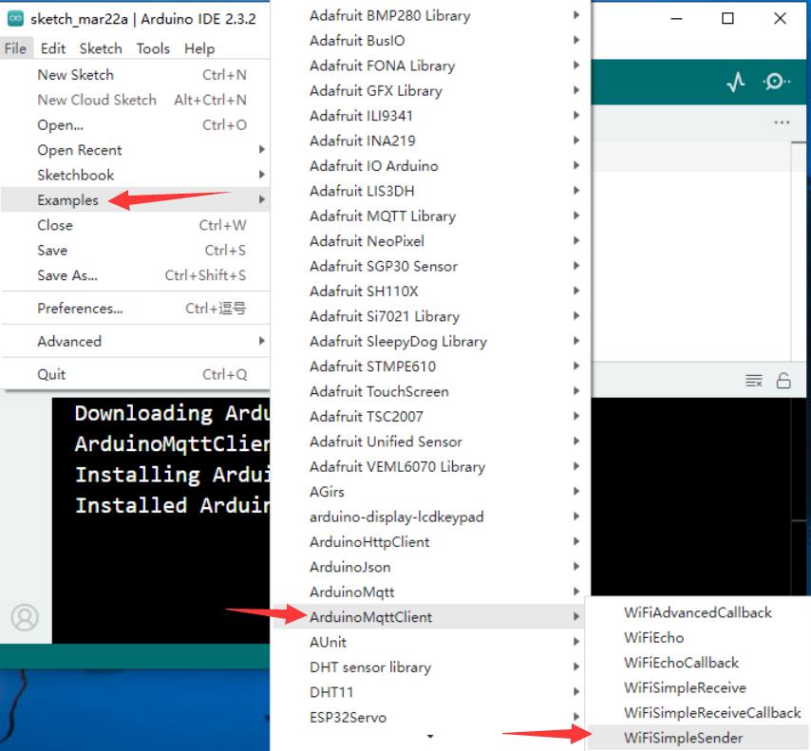

Please modify this part and remove the “//” comment slash to enable the parameter.

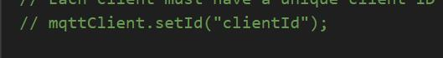

mqttClient.setId(“YOUR_CLIENT_ID”) , define your client ID, but do not use digital number as beginning. NOTE: the broker server will deny the message if the message does not contain a unique client ID.

Next step is to modify the broker’s information, here you need to replace the IP address to your own broker server’s IP and port.

for example: here is my own testing broker server:

const char broker[] = "192.168.3.109";

int port = 1883;

If you use your own Raspberry Pi to be a broker server, please input your Raspberry Pi’s IP address.

const char broker[] = "192.168.3.109";

int        port     = 1883;

const char topic1[]  = "uno/temp_in1";

const char topic2[]  = "uno/humidity";

const char topic3[]  = "uno/temp_in2";

const char topic4[]  = "uno/pressure";

const char topic5[]  = "uno/altitude";

const char topic6[]  = "home/bedroom/switch1/set";

This topic should be created on broker server, here is an example, I have already created a topic called “uno/temp_in1”, it should modify the configuration.yaml in your Home Assistant Docker environment, I will talk about it later.

And at the same time, you need to apply the SSID and Password information of your own router, so that the arduino UNO R4 Wi-Fi board can associate to the AP and get the IP address and NETMASK, GATEWAY, DNS server from your router. NOTE: please make sure DHCP service works properly on your router.

Here is one part of the demo code. you can put your ssid and password information in arduino_secret.h header file.

#include <ArduinoMqttClient.h>

#include <WiFiS3.h>

#include "ArduinoGraphics.h"

#include "Arduino_LED_Matrix.h"

#include <string.h>

#include <stdlib.h>

#include <DHT11.h>

#include <Wire.h>

#include <Adafruit_Sensor.h>

#include <Adafruit_BMP280.h>

Adding the header file to operate the BMP280 air pressure sensor, and temperature and humidity sensor.

* Define the device’s I2C address. Create an instance object called bmp280.

#define BMP280_I2C_ADDRESS 0x76

Adafruit_BMP280 bmp280;

* Make sure the network SSID and password has been adding to arduino_secrets.h file in a new tab.

///////please enter your sensitive data in the Secret tab/arduino_secrets.h

char ssid[] = SECRET_SSID;    // your network SSID (name)

char pass[] = SECRET_PASS;    // your network password (use for WPA, or use as key for WEP)

* Connect OUT pin from DHT11 to arduino UNO R4 Wi-Fi’s 7 Pin.

#define DHT11PIN 7

* Create a new instance of temperature and humidity sensor, called dht11.

DHT11 dht11(DHT11PIN);

create a new instance of wificClient and then pass it to MqttClient class to create an instance of mqttClient.

WiFiClient wifiClient;

MqttClient mqttClient(wifiClient);

* Define some variables to store the information of broker and topics.

const char broker[] = "192.168.3.109";

int        port     = 1883;

const char topic1[]  = "uno/temp_in1";

const char topic2[]  = "uno/humidity";

const char topic3[]  = "uno/temp_in2";

const char topic4[]  = "uno/pressure";

const char topic5[]  = "uno/altitude";

const char topic6[]  = "home/bedroom/switch1/set";

* Define the buzzer connected pin number.

int buzzerPin = 9;

* Define a function to draw text on LED matrix onboard.

void drawText(const char text[]){

  matrix.beginDraw();

  matrix.stroke(0xFFFFFFFF);

  matrix.textScrollSpeed(50);

  // add the text

  matrix.textFont(Font_5x7);

  matrix.beginText(0, 1, 0xFFFFFF);

  matrix.println(text);

  matrix.endText(SCROLL_LEFT);

  matrix.endDraw();

}

* Setup function part

void setup() {

  // initializing

  pinMode(DHT11PIN, INPUT);

  pinMode(buzzer, OUTPUT);

  digitalWrite(buzzer, LOW); // turn off buzzer

// init bmp280 sensor

 if (!bmp280.begin(BMP280_I2C_ADDRESS)){

    Serial.println("Could not find a valid BMP280 sensor, check wiring!!!");

    while(1);

  }

  // init matrix and setting renderbitmap.

  matrix.begin();

  matrix.renderBitmap(frame, 8, 12);

  // init serial port

  Serial.begin(9600);

  while (!Serial) {

    ;  // wait for serial port to connect. Needed for native USB port only

  }

  // attempt to connect to WiFi network:

  Serial.print("Attempting to connect to WPA SSID: ");

  Serial.println(ssid);

  while (WiFi.begin(ssid, pass) != WL_CONNECTED) {

    // failed, retry

    Serial.print(".");

    delay(5000);

  }

  Serial.print("IP address:");

  Serial.println(WiFi.localIP());

  Serial.println("You're connected to the network");

  Serial.println();

  // You can provide a unique client ID, if not set the library uses Arduino-millis()

  // Each client must have a unique client ID

  mqttClient.setId("uno_R4_01");

  // You can provide a username and password for authentication

  mqttClient.setUsernamePassword("jacky", "mypassword");

  Serial.print("Attempting to connect to the MQTT broker: ");

  Serial.println(broker);

  if (!mqttClient.connect(broker, port)) {

    Serial.print("MQTT connection failed! Error code = ");

    Serial.println(mqttClient.connectError());

    while (1){

    if (!mqttClient.connect(broker, port)) {

    Serial.print("MQTT connection failed! Error code = ");

    Serial.println(mqttClient.connectError());

      }

    }

  }

  Serial.println("You're connected to the MQTT broker!");

  Serial.println();

  Serial.println("Sending available to topic!");

  // send message, the Print interface can be used to set the message contents

  mqttClient.beginMessage("home/bedroom/switch1/available");

  mqttClient.print("online");

  mqttClient.endMessage();

  Serial.println();

  mqttClient.onMessage(onMqttMessage);

  mqttClient.subscribe("home/bedroom/switch1/set");

}

* Create a callback function

If data is sent from the Home assistant, such as a button switching operation, and we hope to obtain the corresponding value, we need to use a callback function to process the received information.

Here, if arduino receives an ON message through the topic, it will display ON on the LED matrix and turn on the buzzer. If it receives an OFF message, it will display OFF on the LED matrix and turn off the buzzer.

 void onMqttMessage(int messageSize) {

  char command[3];

  int i = 0;

  if (mqttClient.messageTopic().equals("home/bedroom/switch1/set")) {

    while (mqttClient.available()) {

      command[i++] = (char)mqttClient.read();

    }

    if (command[0] == 'O' && command[1] == 'N') {

      Serial.println("on led");

      digitalWrite(buzzer, HIGH);

       drawText("  ON!  ");

    } else if (command[0] == 'O' && command[1] == 'F' && command[2] == 'F') {

      Serial.println("off led");

      digitalWrite(buzzer, LOW);

       drawText("  OFF!  ");

    }

  };

}

* Get IP address part

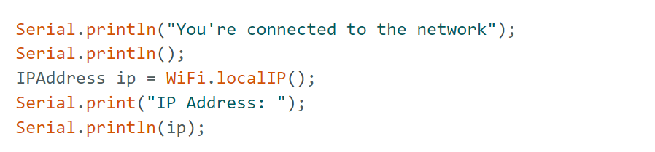

* Configure mqttClient connection information：

What needs to be noted here is the part that requires authentication：

// You can provide a username and password for authentication

  mqttClient.setUsernamePassword("jacky", "mypassword");

* The loop section

The sending of data is completed by three functions respectively.

* mqttClient.beginMessage(topic1); topic1 here is our topic. Customize it on the server first.
* mqttClient.print(bmp_temp); Here is the message content.
* mqttClient.endMessage(); is sent after completion.

void loop() {

  // call poll() regularly to allow the library to send MQTT keep alives which

  // avoids being disconnected by the broker

  mqttClient.poll();

  delay(1);

  delay_cnt++;

  if (delay_cnt == 100) {

    // read data from DHT11 sensor

    float humidity = dht11.readHumidity();

    float temperature = dht11.readTemperature();

    Serial.print(temperature);

    Serial.print("\t");

    Serial.print(humidity);

    Serial.print("\t");

    mqttClient.beginMessage(topic1);

    mqttClient.print(temperature);

    mqttClient.endMessage();

    mqttClient.beginMessage(topic2);

    mqttClient.print(humidity);

    mqttClient.endMessage();

  } else if (delay_cnt == 200) {

    // read temperature, pressure and altitude from BMP280 sensor

    float bmp_temp = bmp280.readTemperature();                    //

    float bmp_pressure = bmp280.readPressure() / 100.0;         //Read Pressure in Pa and conversion to inches of mercury;

    float bmp_altitude = bmp280.readAltitude(1013.25);  //Calculating the Altitude, the "1013.25"  is the pressure in(hPa) at sea level at day in your region

    Serial.print(bmp_temp);

    Serial.print("\t");

    Serial.print(bmp_pressure);

    Serial.print("\t");

    Serial.print(bmp_altitude);

    Serial.print("\t\t");

    mqttClient.beginMessage(topic3);

    mqttClient.print(bmp_temp);

    mqttClient.endMessage();

    mqttClient.beginMessage(topic4);

    mqttClient.print(bmp_pressure);

    mqttClient.endMessage();

    mqttClient.beginMessage(topic5);

    mqttClient.print(bmp_altitude);

    mqttClient.endMessage();

  } else if (delay_cnt == 500) {

    delay_cnt = 0;

  }

}

### Compile & Upload sketch

Then select the device and click Upload.

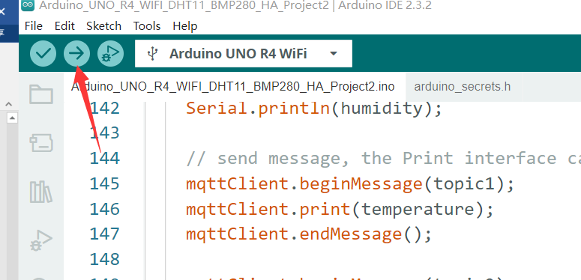

## Home Assistant Part

* First, open a browser and access Home assistant backend, and then login with the username name and password created before.

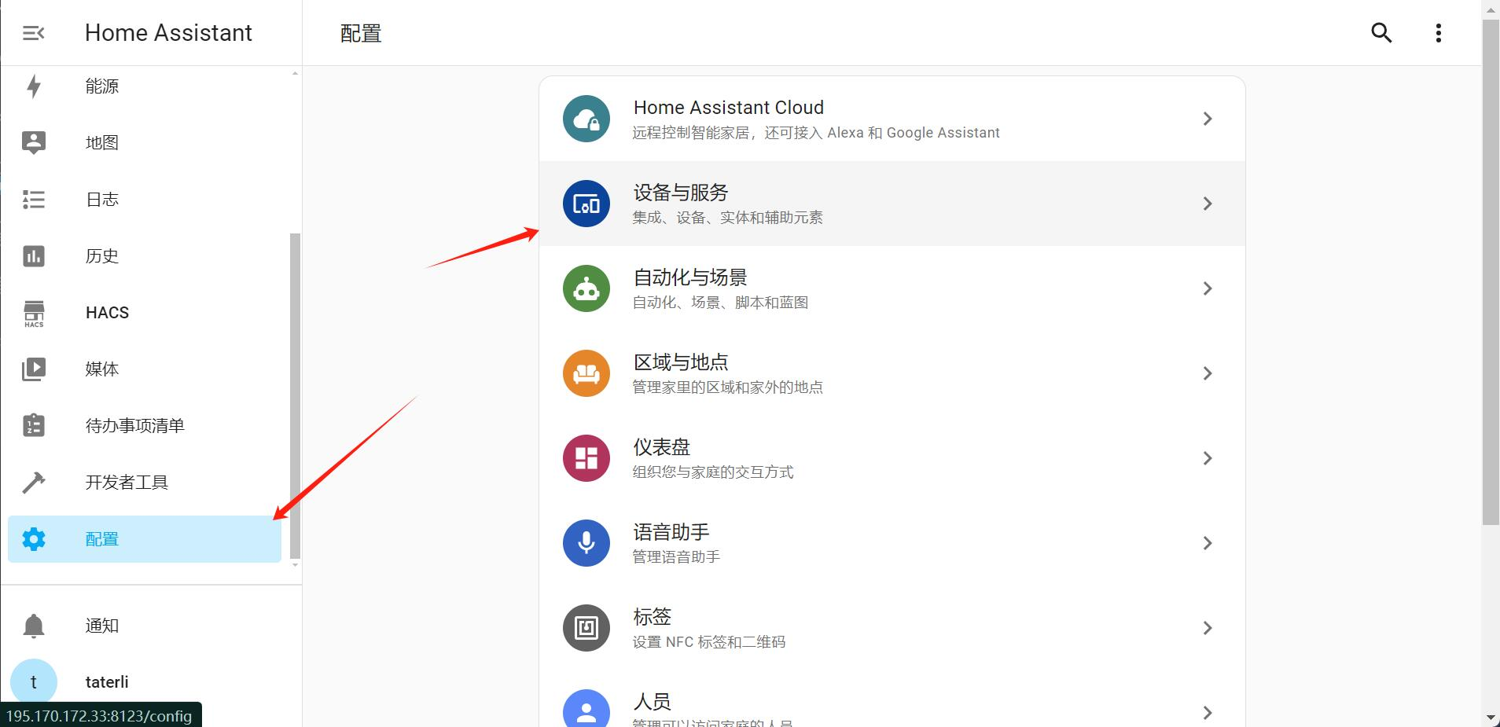

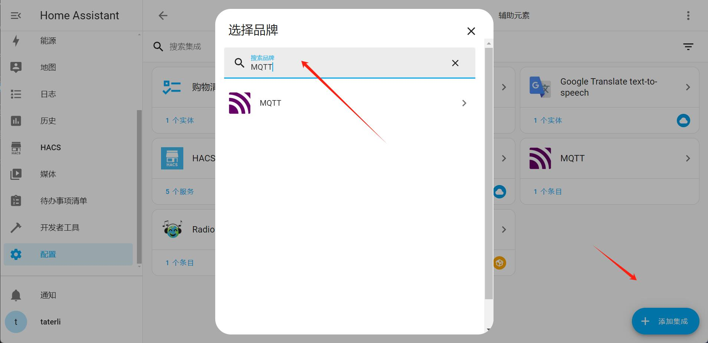

* Login to Raspberry Pi via SSH or login directly at localhost.
* Modify /opt/homeassistant/configuration.yaml file and adding following parameters:

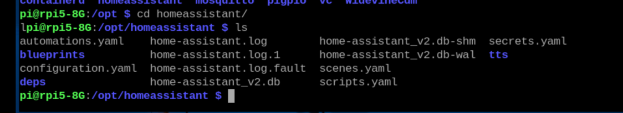

parameters like:

mqtt:

  sensor:

    - name: "DHT11 - Temperatue "

      state_topic: "uno/temp_in1"

      unit_of_measurement: "C"

      value_template: "{{ value }}"

    - name: "DHT11 - Humidity"

      state_topic: "uno/humidity"

      unit_of_measurement: "%"

      value_template: "{{ value }}"

    - name: "BMP280 - Temperature"

      state_topic: "uno/temp_in2"

      unit_of_measurement: "C"

      value_template: "{{ value }}"

    - name: "BMP280 - Pressure"

      state_topic: "uno/pressure"

      unit_of_measurement: "HPa"

      value_template: "{{ value }}"

    - name: "BMP280 - Altitude"

      state_topic: "uno/altitude"

      unit_of_measurement: "m"

      value_template: "{{ value }}"

Here is the final result:

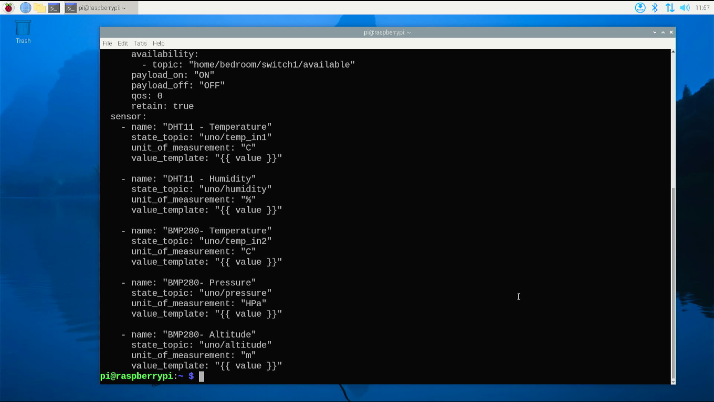

### Restart Home assistant

You need to restart Home assistant to take effect.

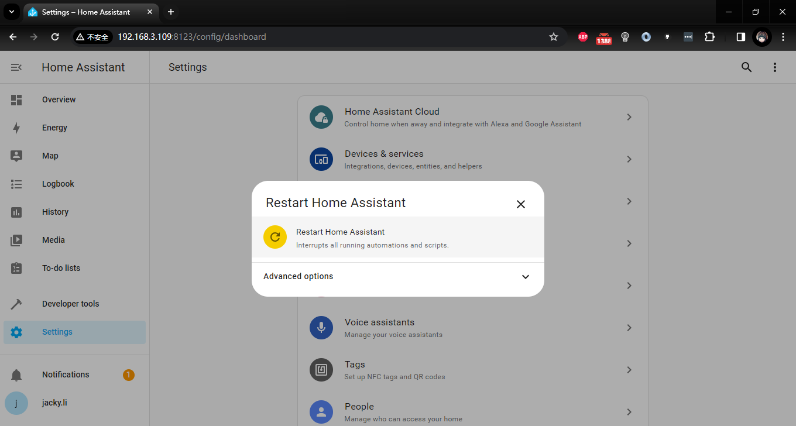

### Basic operation

After restarting, click overview icon

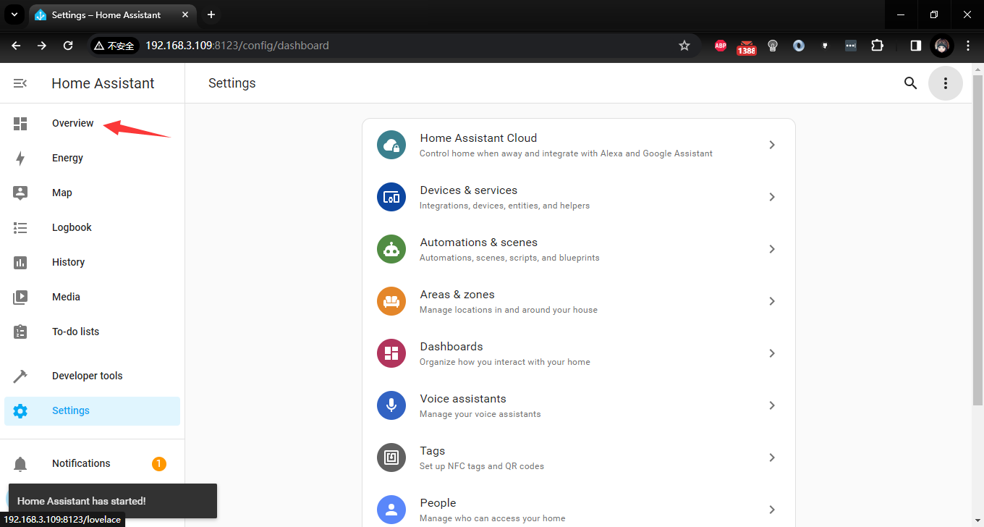

You will see the default information which is sending from Arduino Uno R4 Wi-Fi.

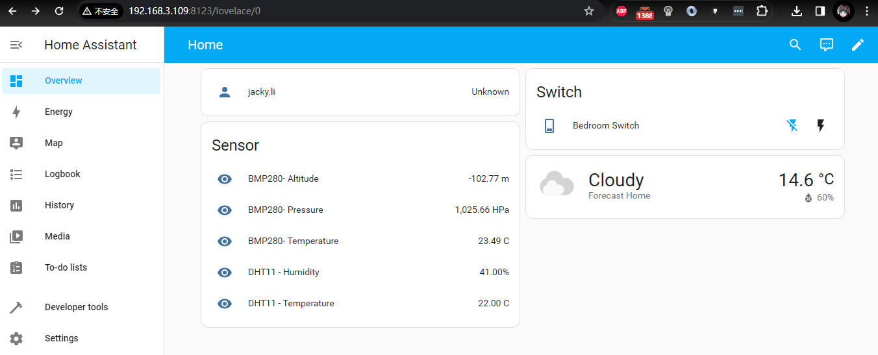

Click following icon will trigger the buzzer beeping.

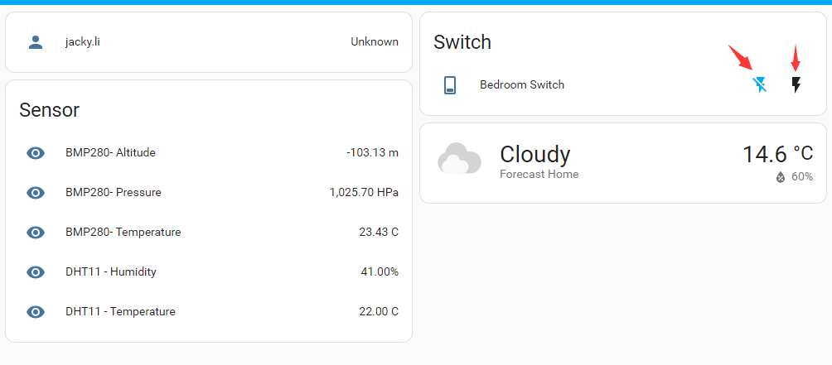

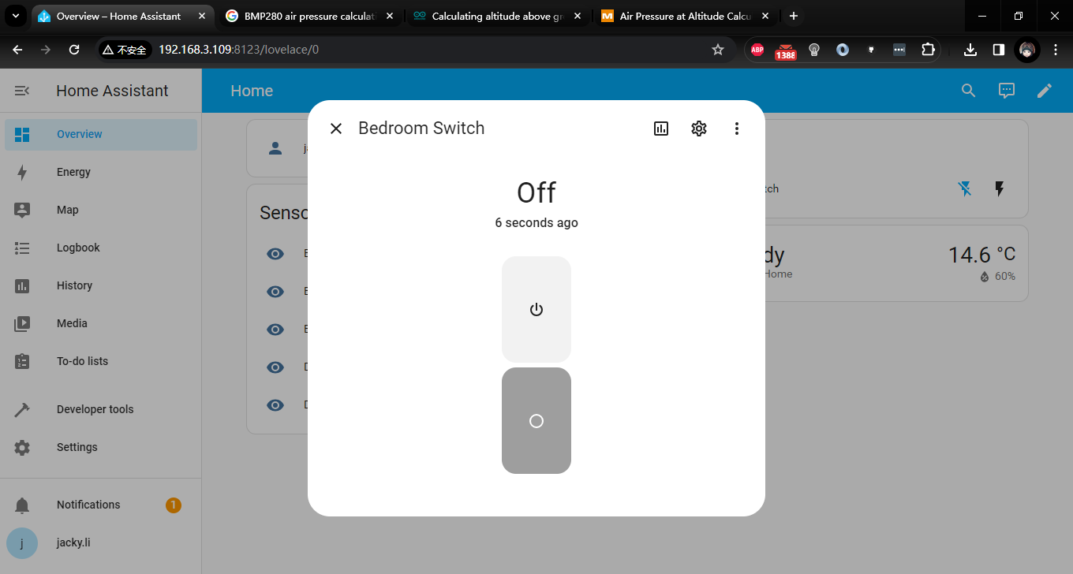

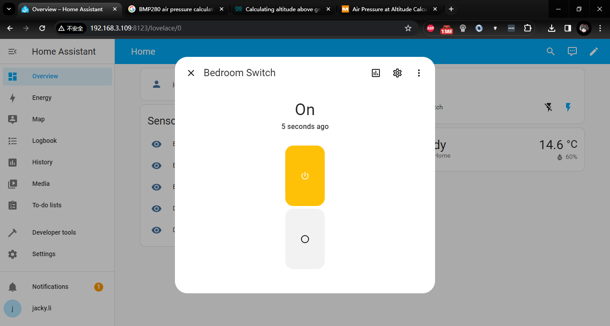

And the LED matrix will show a text “ON!” scrolling.

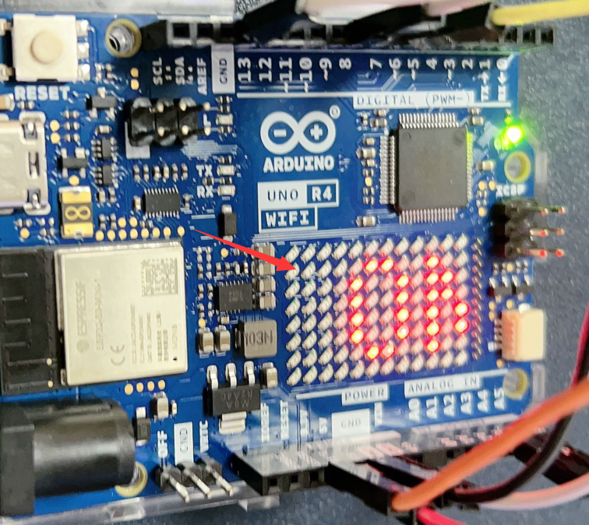

## Project Description

This code implements a sensor data acquisition and control system based on MQTT. It connects to an MQTT broker via Wi-Fi, sends sensor readings to specific topics, and is capable of receiving control commands from designated topics to control the status of LED lights and a buzzer. Additionally, it displays corresponding messages on an LED matrix.

### Demo code

#include <ArduinoMqttClient.h>

#include <WiFiS3.h>

#include "ArduinoGraphics.h"

#include "Arduino_LED_Matrix.h"

#include <string.h>

#include <stdlib.h>

#include <DHT11.h>

#include <Wire.h>

#include <Adafruit_Sensor.h>

#include <Adafruit_BMP280.h>

#include "arduino_secrets.h"

///////please enter your sensitive data in the Secret tab/arduino_secrets.h

char ssid[] = SECRET_SSID;  // your network SSID (name)

char pass[] = SECRET_PASS;  // your network password (use for WPA, or use as key for WEP)

ArduinoLEDMatrix matrix;  // create an instance for led matrix.

// create an instance of BMP280 sensor, it will create an object called bmp280

#define BMP280_I2C_ADDRESS 0x76

Adafruit_BMP280 bmp280;

#define DHT11PIN 7      //DHT 11 sensor

DHT11 dht11(DHT11PIN);  // create an instance of dht11

// bitmap frame buffer.

byte frame[8][12] = {

  { 0, 0, 1, 1, 0, 0, 0, 1, 1, 0, 0, 0 },

  { 0, 1, 0, 0, 1, 0, 1, 0, 0, 1, 0, 0 },

  { 0, 1, 0, 0, 0, 1, 0, 0, 0, 1, 0, 0 },

  { 0, 0, 1, 0, 0, 0, 0, 0, 1, 0, 0, 0 },

  { 0, 0, 0, 1, 0, 0, 0, 1, 0, 0, 0, 0 },

  { 0, 0, 0, 0, 1, 0, 1, 0, 0, 0, 0, 0 },

  { 0, 0, 0, 0, 0, 1, 0, 0, 0, 0, 0, 0 },

  { 0, 0, 0, 0, 0, 0, 0, 0, 0, 0, 0, 0 }

};

// To connect with SSL/TLS:

// 1) Change WiFiClient to WiFiSSLClient.

// 2) Change port value from 1883 to 8883.

// 3) Change broker value to a server with a known SSL/TLS root certificate

//    flashed in the WiFi module.

WiFiClient wifiClient;

MqttClient mqttClient(wifiClient);

const char broker[] = "192.168.3.109";

int port = 1883;

const char topic1[] = "uno/temp_in1";

const char topic2[] = "uno/humidity";

const char topic3[] = "uno/temp_in2";

const char topic4[] = "uno/pressure";

const char topic5[] = "uno/altitude";

const char topic6[] = "home/bedroom/switch1/set";

// define buzzer pin

const int buzzer = 9;

// LED matrix drawText function

void drawText(const char text[]) {

  matrix.beginDraw();

  matrix.stroke(0xFFFFFFFF);

  matrix.textScrollSpeed(50);

  // add the text

  matrix.textFont(Font_5x7);

  matrix.beginText(0, 1, 0xFFFFFF);

  matrix.println(text);

  matrix.endText(SCROLL_LEFT);

  matrix.endDraw();

}

void setup() {

  pinMode(7, INPUT);

  pinMode(buzzer, OUTPUT);

  digitalWrite(buzzer, LOW);  // turn off buzzer

  // init matrix and setting renderbitmap.

  matrix.begin();

  matrix.renderBitmap(frame, 8, 12);

  // init bmp280

  if (!bmp280.begin(BMP280_I2C_ADDRESS)){

    Serial.println("Could not find a valid BMP280 sensor, check wiring!!!");

    while(1);

  }

  // init serial port

  Serial.begin(9600);

  while (!Serial) {

    ;  // wait for serial port to connect. Needed for native USB port only

  }

  // attempt to connect to WiFi network:

  Serial.print("Attempting to connect to WPA SSID: ");

  Serial.println(ssid);

  while (WiFi.begin(ssid, pass) != WL_CONNECTED) {

    // failed, retry

    Serial.print(".");

    delay(5000);

  }

  Serial.print("IP address:");

  Serial.println(WiFi.localIP());

  Serial.println("You're connected to the network");

  Serial.println();

  // You can provide a unique client ID, if not set the library uses Arduino-millis()

  // Each client must have a unique client ID

  mqttClient.setId("uno_R4_01");

  // You can provide a username and password for authentication

  mqttClient.setUsernamePassword("jacky", "mypassword");

  Serial.print("Attempting to connect to the MQTT broker: ");

  Serial.println(broker);

  if (!mqttClient.connect(broker, port)) {

    Serial.print("MQTT connection failed! Error code = ");

    Serial.println(mqttClient.connectError());

    while (1) {

      if (!mqttClient.connect(broker, port)) {

        Serial.print("MQTT connection failed! Error code = ");

        Serial.println(mqttClient.connectError());

      }

    }

  }

  Serial.println("You're connected to the MQTT broker!");

  Serial.println();

  Serial.println("Sending available to topic!");

  // send message, the Print interface can be used to set the message contents

  mqttClient.beginMessage("home/bedroom/switch1/available");

  mqttClient.print("online");

  mqttClient.endMessage();

  Serial.println();

  mqttClient.onMessage(onMqttMessage);

  mqttClient.subscribe("home/bedroom/switch1/set");

}

void onMqttMessage(int messageSize) {

  char command[3];

  int i = 0;

  if (mqttClient.messageTopic().equals("home/bedroom/switch1/set")) {

    while (mqttClient.available()) {

      command[i++] = (char)mqttClient.read();

    }

    if (command[0] == 'O' && command[1] == 'N') {

      Serial.println("on led");

      digitalWrite(buzzer, HIGH);

      drawText("  ON!  ");

    } else if (command[0] == 'O' && command[1] == 'F' && command[2] == 'F') {

      Serial.println("off led");

      digitalWrite(buzzer, LOW);

      drawText("  OFF!  ");

    }

  };

}

int delay_cnt = 0;

void loop() {

  // call poll() regularly to allow the library to send MQTT keep alives which

  // avoids being disconnected by the broker

  mqttClient.poll();

  delay(1);

  delay_cnt++;

  if (delay_cnt == 100) {

    // read data from DHT11 sensor

    float humidity = dht11.readHumidity();

    float temperature = dht11.readTemperature();

    mqttClient.beginMessage(topic1);

    mqttClient.print(temperature);

    mqttClient.endMessage();

    mqttClient.beginMessage(topic2);

    mqttClient.print(humidity);

mqttClient.endMessage();

  } else if (delay_cnt == 200) {

    // read temperature, pressure and altitude from BMP280 sensor

float bmp_temp = bmp280.readTemperature();

float bmp_pressure = bmp280.readPressure() / 100.0;

//Read Pressure in Pa and conversion to inches of mercury;

float bmp_altitude = bmp280.readAltitude(1013.25);

//Calculating the Altitude, the "1013.25"  is the pressure in(hPa) at sea level at day in your region

    mqttClient.beginMessage(topic3);

    mqttClient.print(bmp_temp);

    mqttClient.endMessage();

    mqttClient.beginMessage(topic4);

    mqttClient.print(bmp_pressure);

    mqttClient.endMessage();

    mqttClient.beginMessage(topic5);

    mqttClient.print(bmp_altitude);

mqttClient.endMessage();

  } else if (delay_cnt == 500) {

    delay_cnt = 0;

  }

}

## Install HACS store

* **Login to Raspberry Pi’s Home assistant Docker Container**

Open a terminal and typing following command to check the container ID and then get into the container:

sudo docker ps -a

sudo docker exec -it  CONTAINER_ID bash

NOTE: replace the CONTAINER_ID to your own CONTAINER_ID.

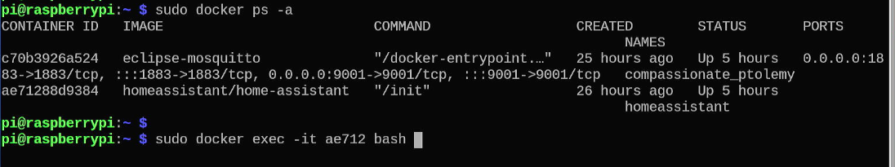

and then you will get into the container.

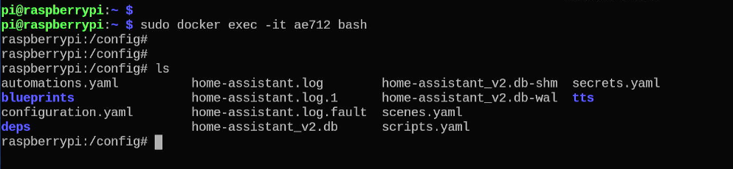

Create two directories: “**custom_components”** and “**www**”, and then create a new directory inside “**custom_components”**, named **“hacs”**

mkdir -pv custom_components/hacs

mkdir -pv www

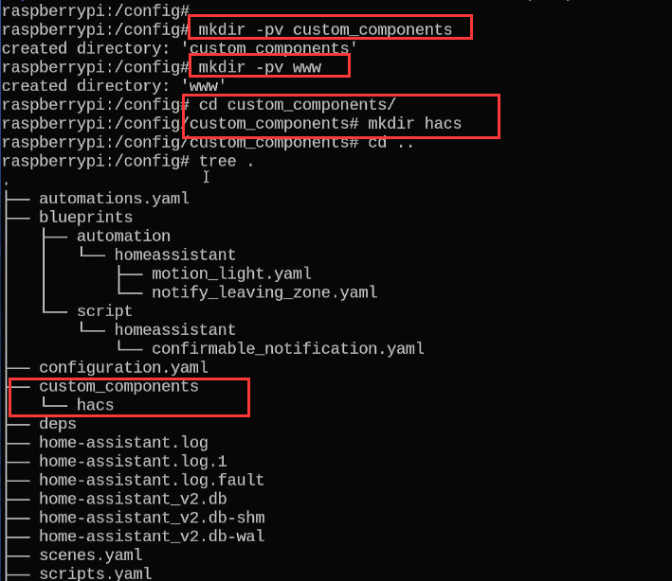

* **Download HACS 1.34.0**

Download source code or release package from following URL to your Raspberry Pi container:

<https://github.com/hacs/integration/releases>

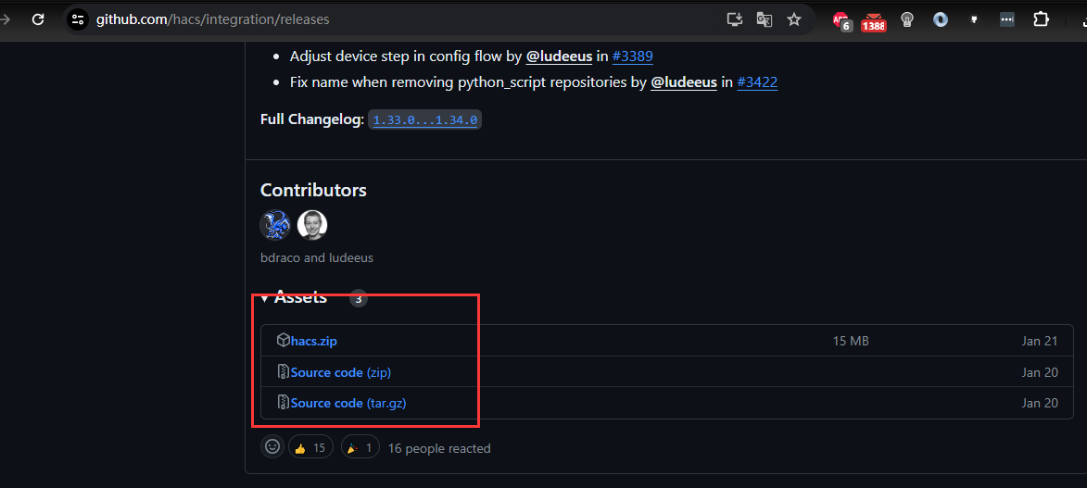

Just right click the Assets and copy link address:

Download the zipped file and then unzip it and upload it to **custom_components/hacs** folder

wget <https://github.com/hacs/integration/releases/download/1.34.0/hacs.zip>

sudo unzip hacs.zip -d /opt/homeassistant/custom_components/hacs/

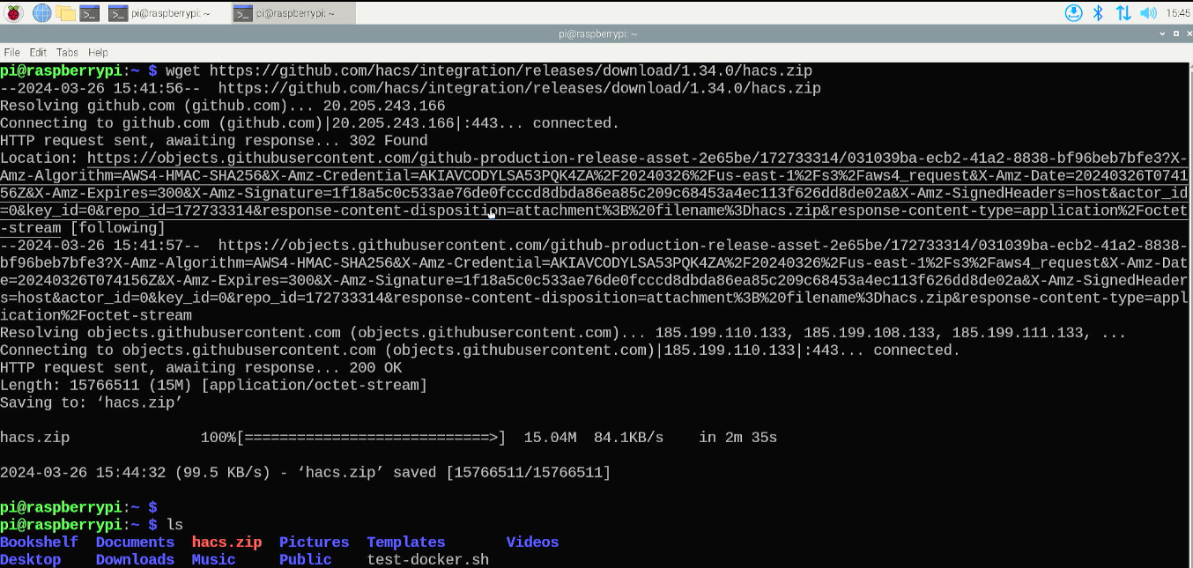

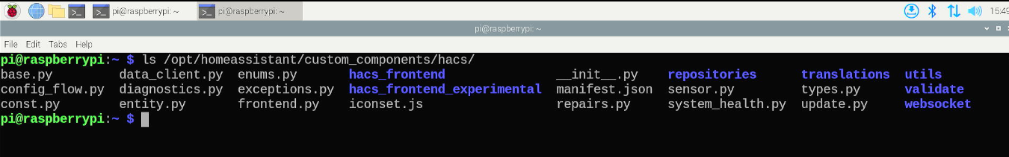

* **Restart Home assistant**

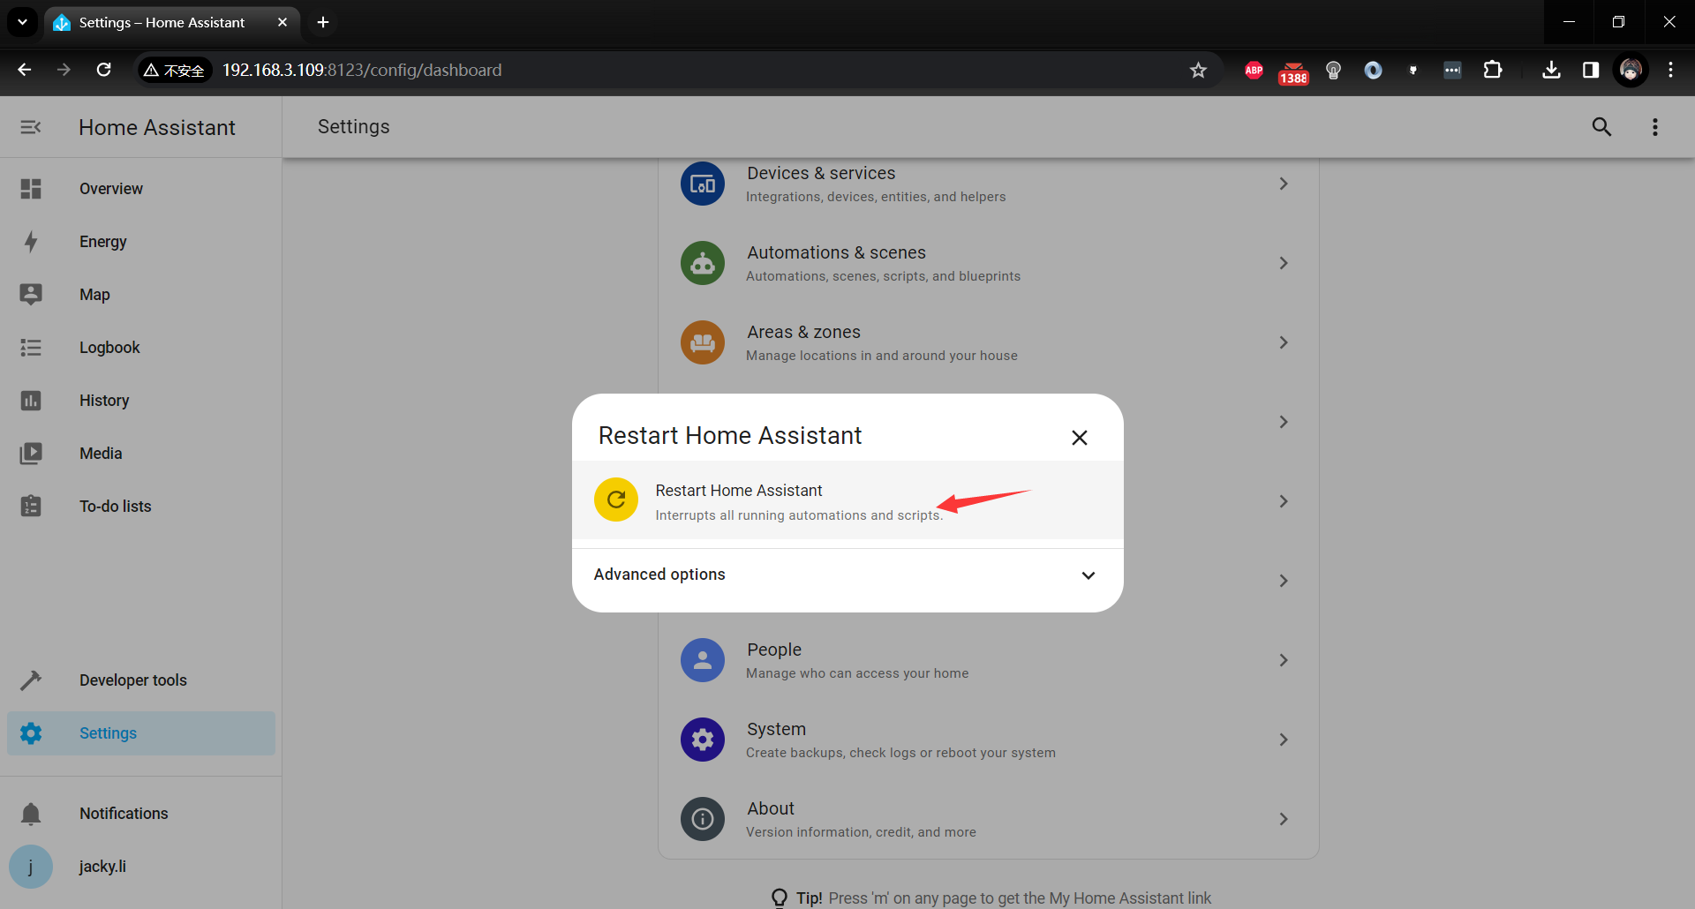

After that, click settings 🡪 Devices & Services

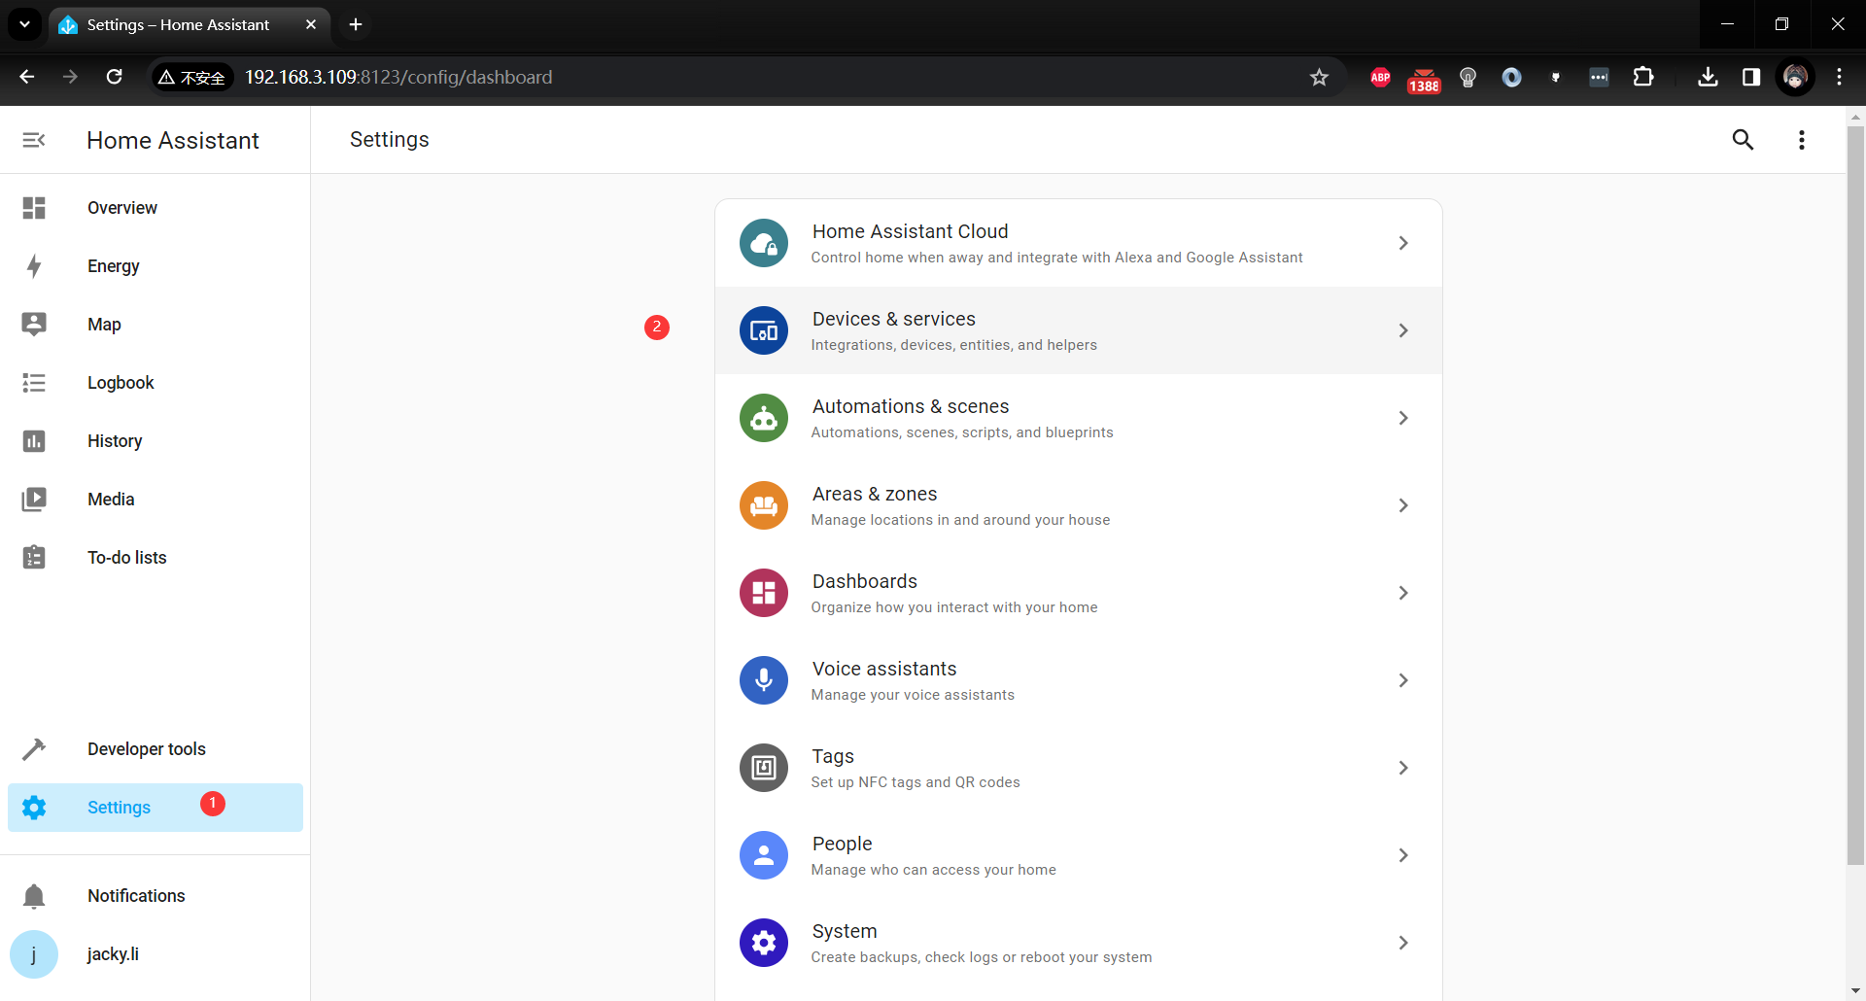

Click +add integration:

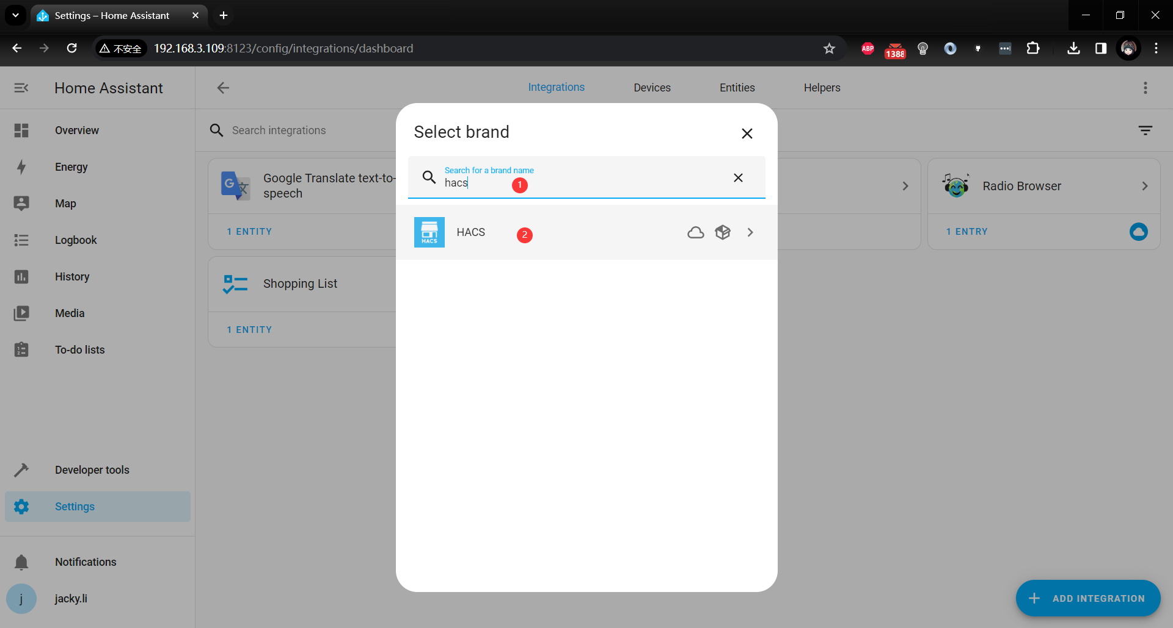

input “HACS” in the search bar.

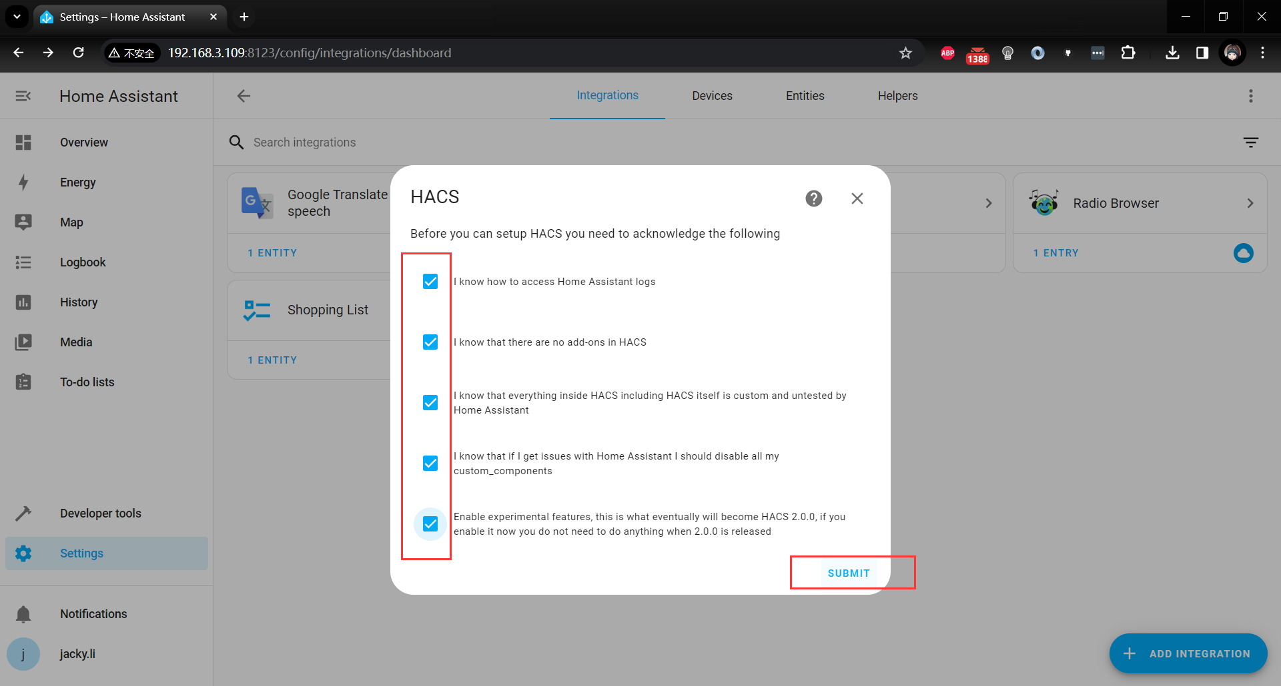

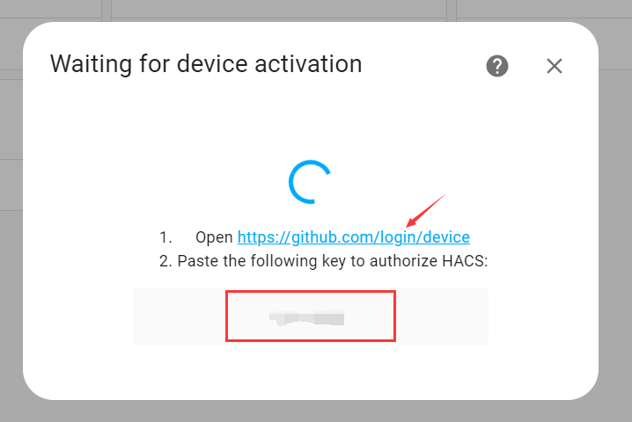

Open GitHub URL, and input the authentication key to authorize HACS.

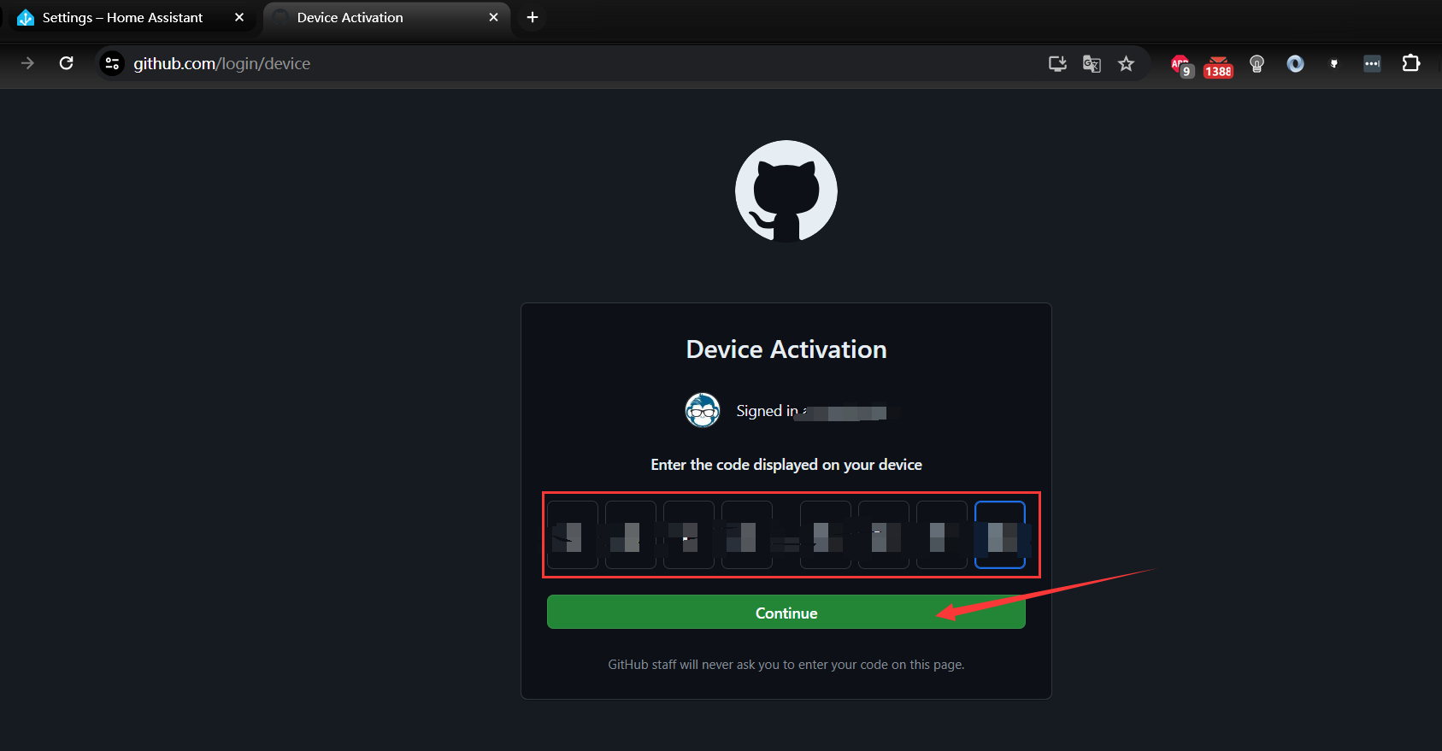

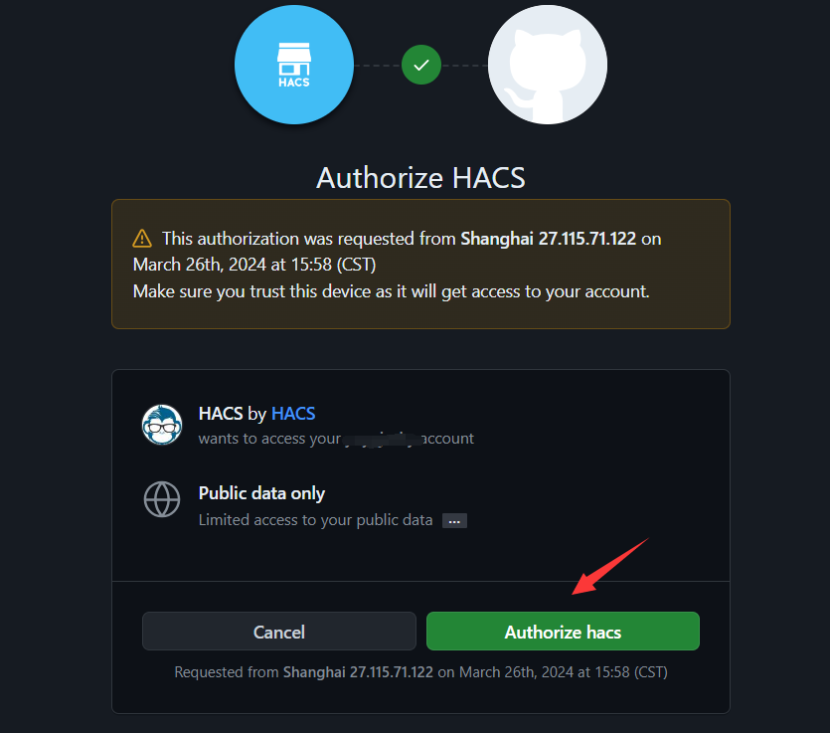

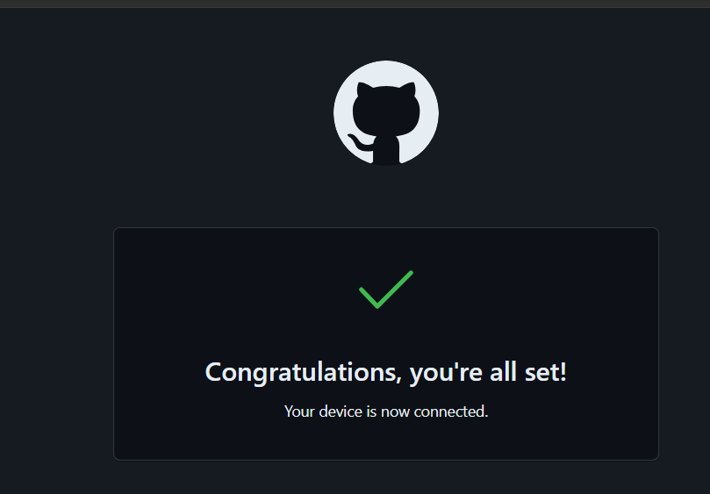

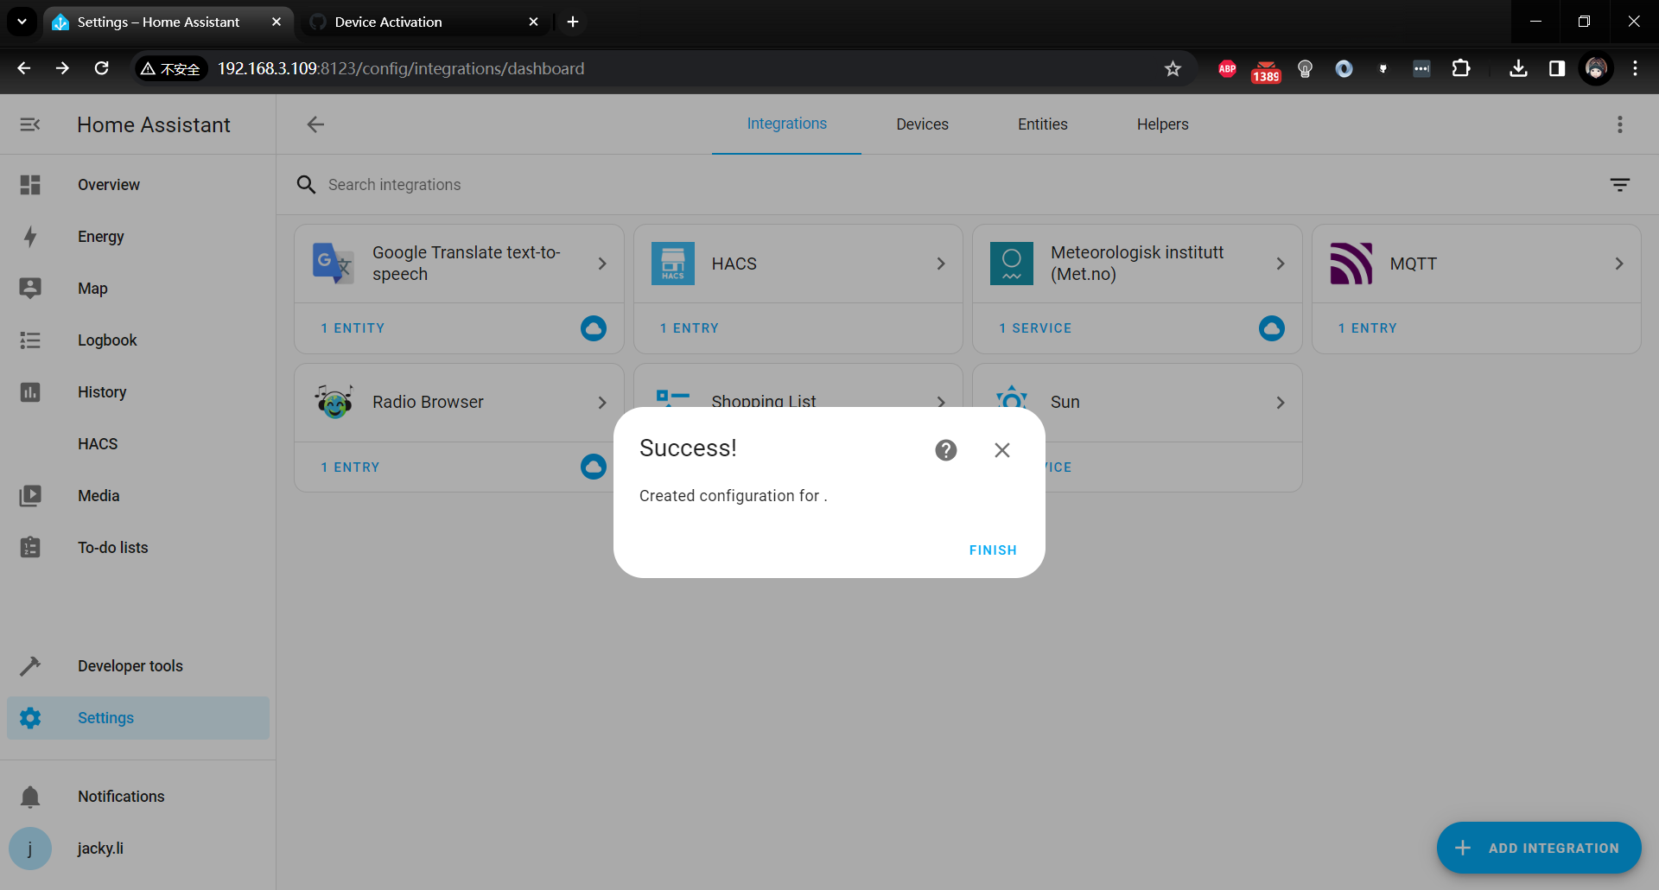

* Restart Home assistant again

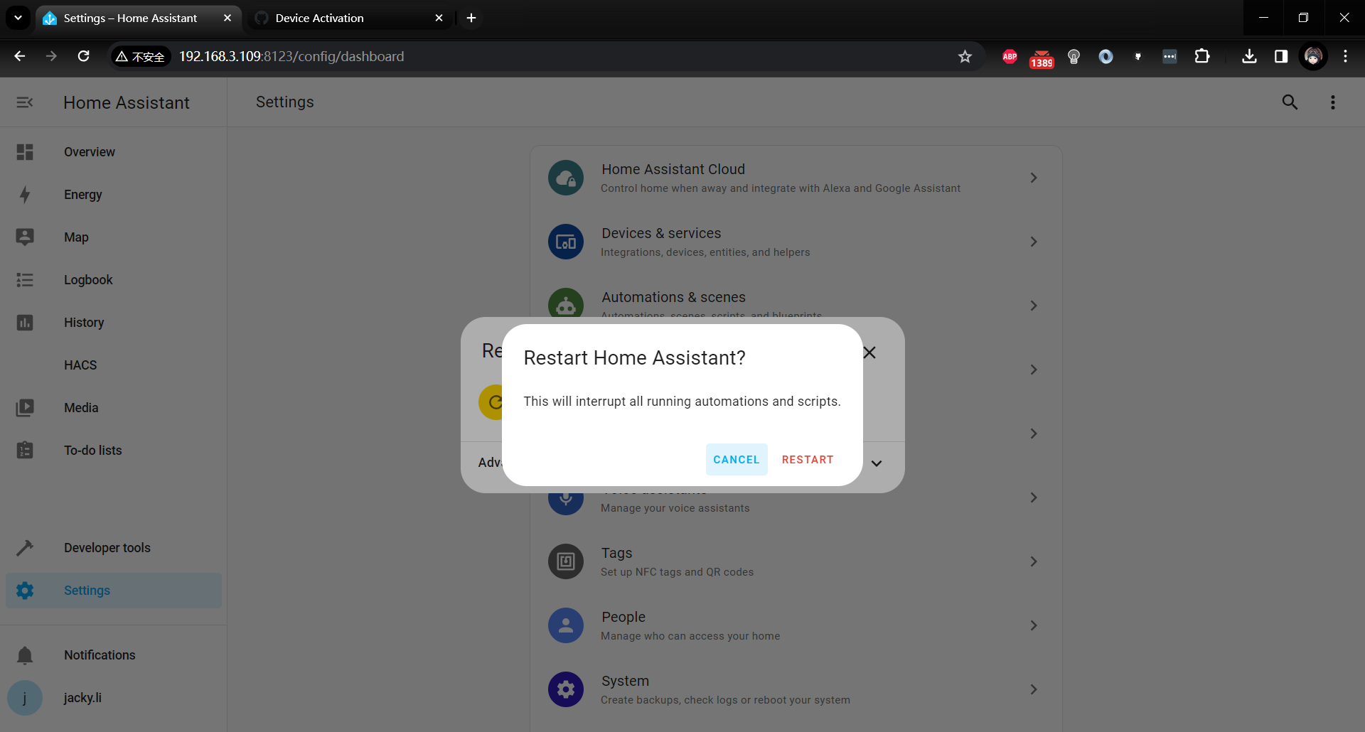

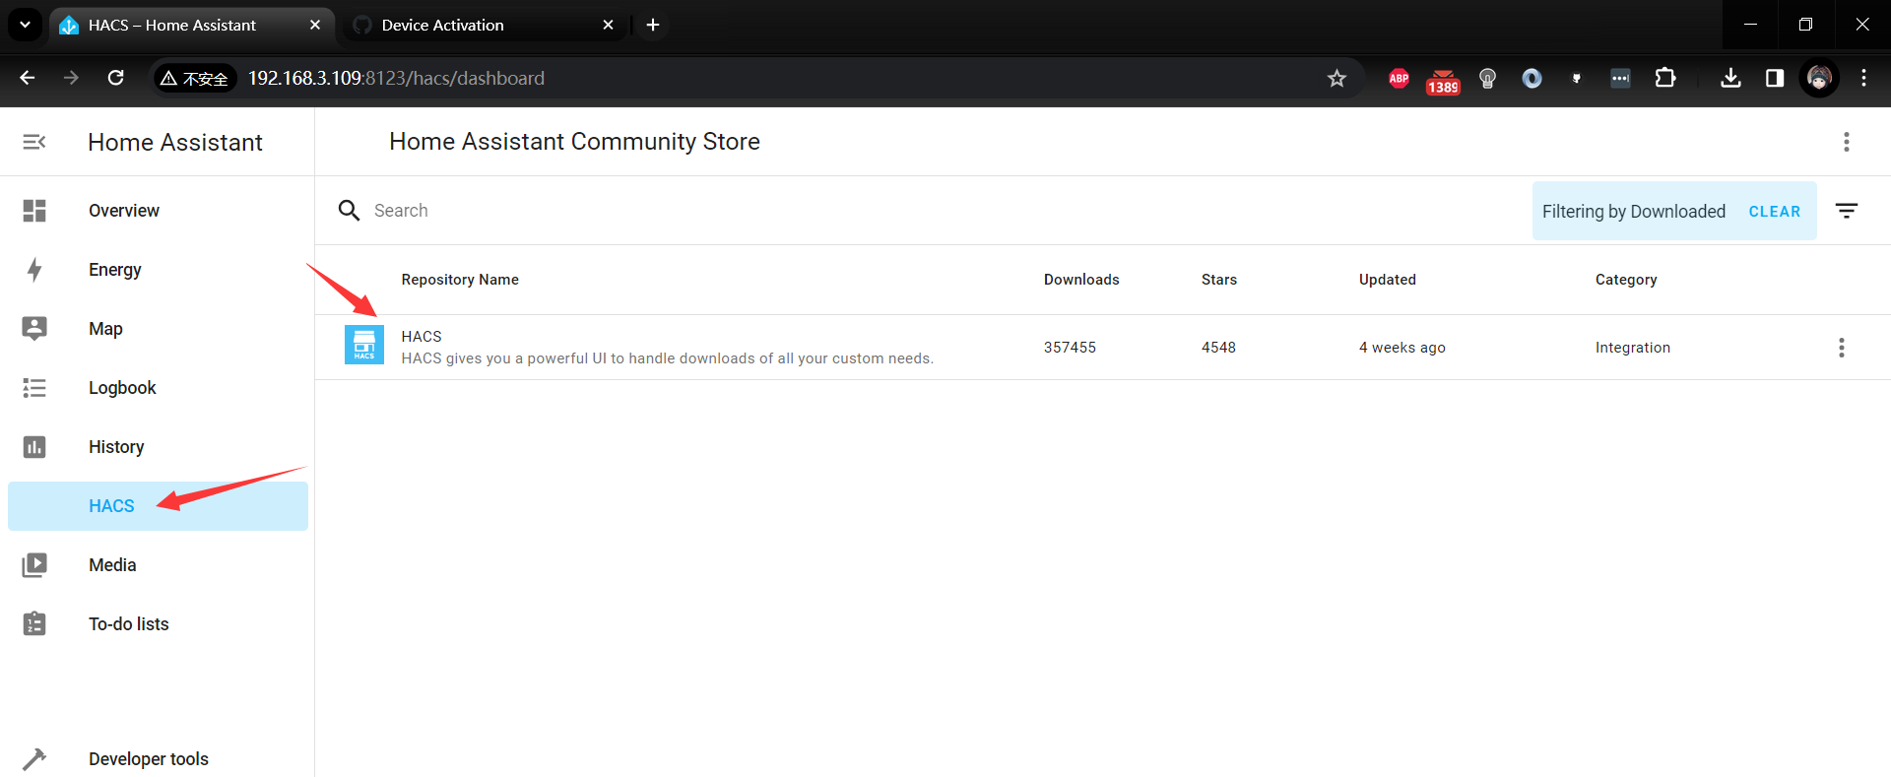

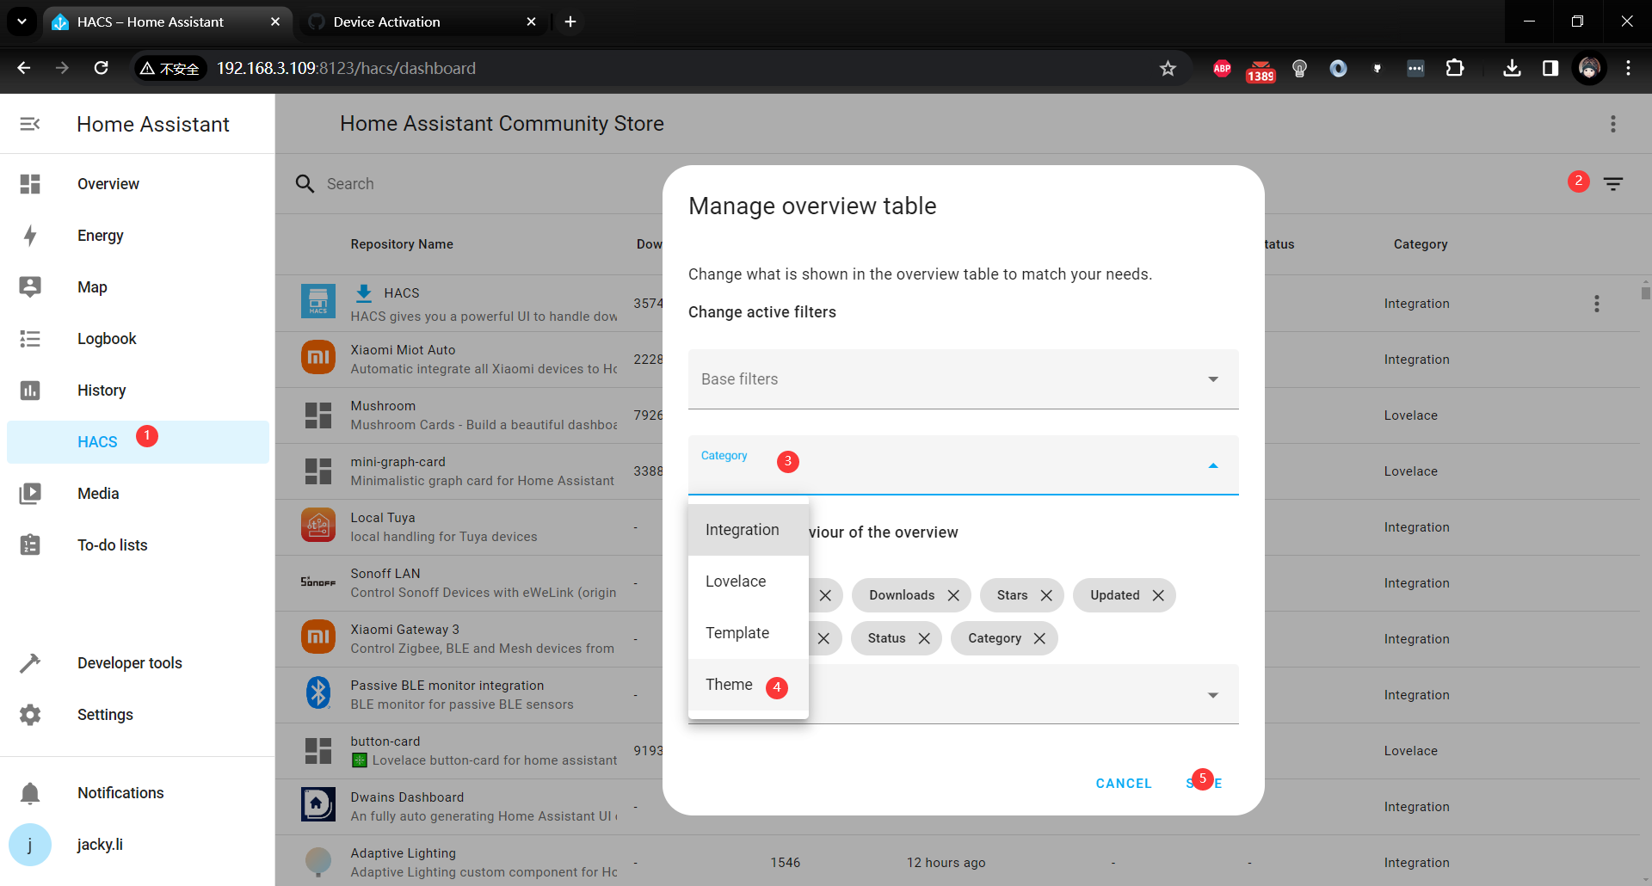

you will find all theme you can use.

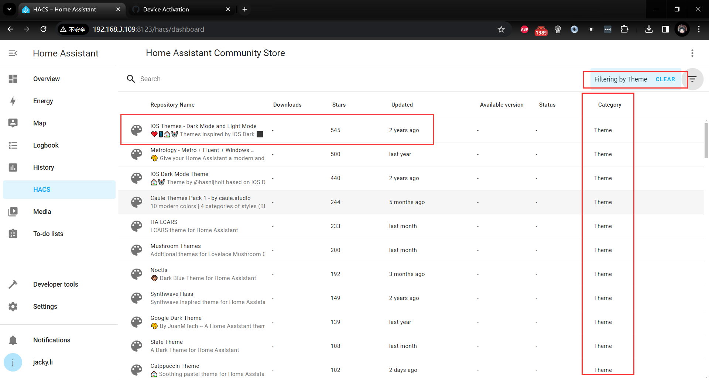

for example, let us chose the first one!

Click download icon to download this theme.

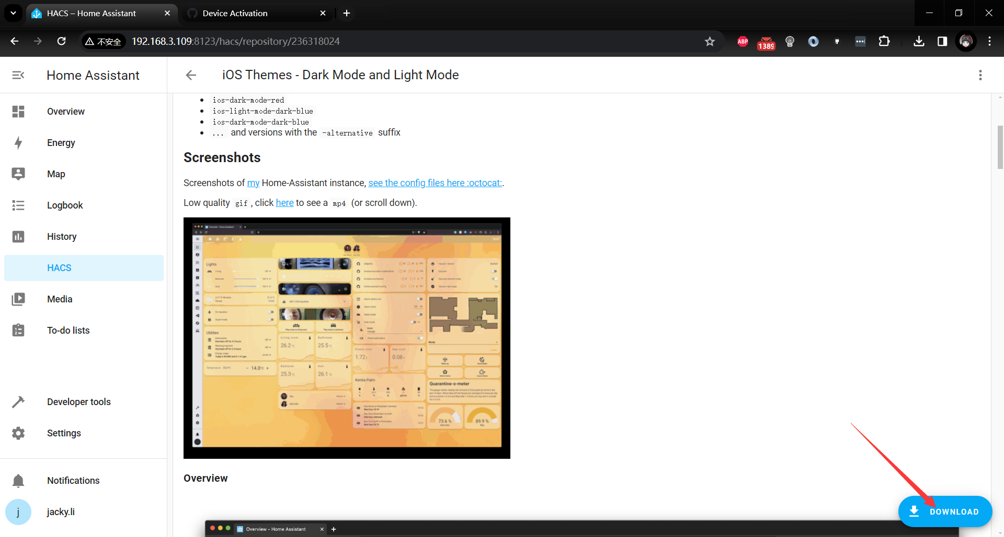

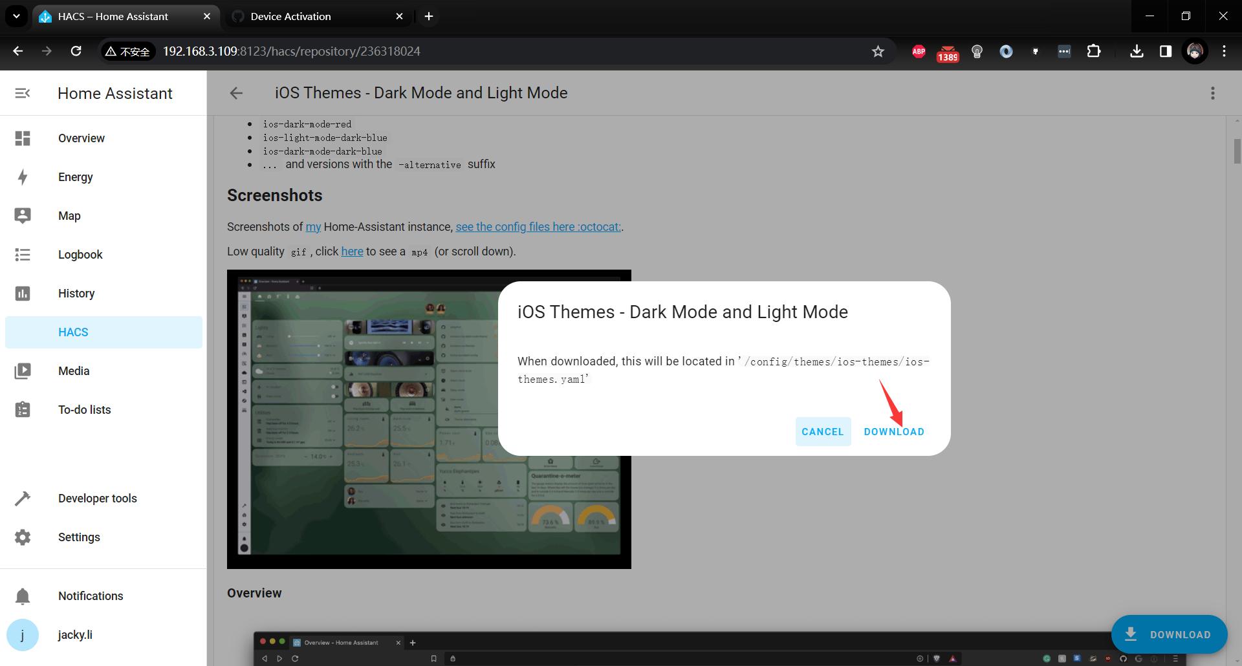

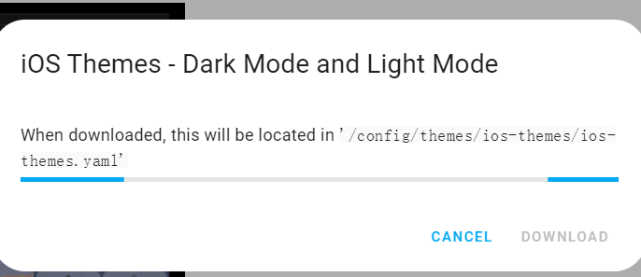

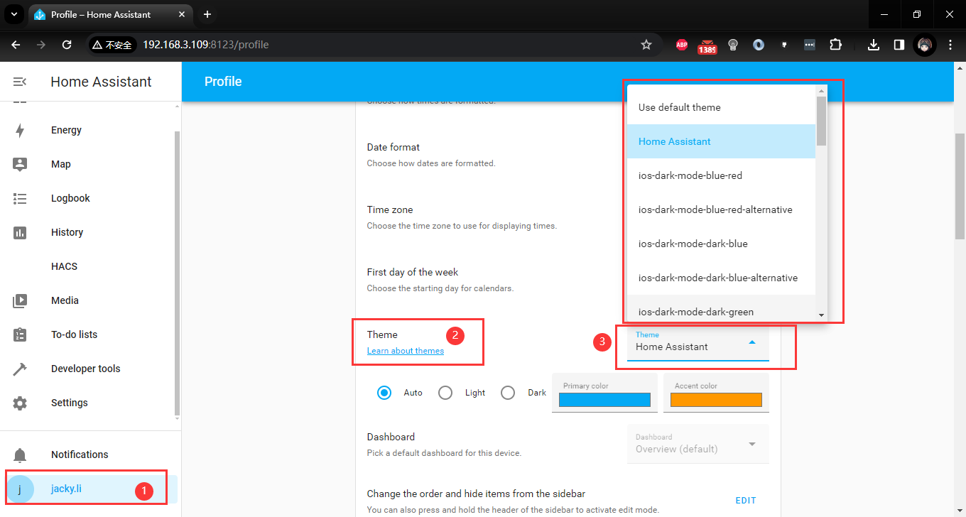

and then go back to overview icon

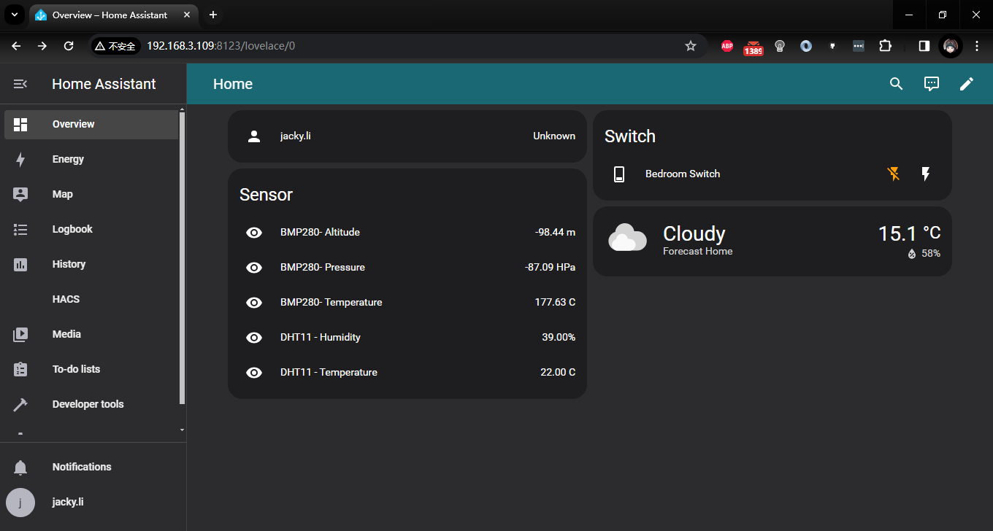

## Install frontend

* Install HACS if you don’t have it already
* Open HACS in Home Assistant
* Go to “Fronted” section
* Click button with “+” icon
* Search for “Mushroom”

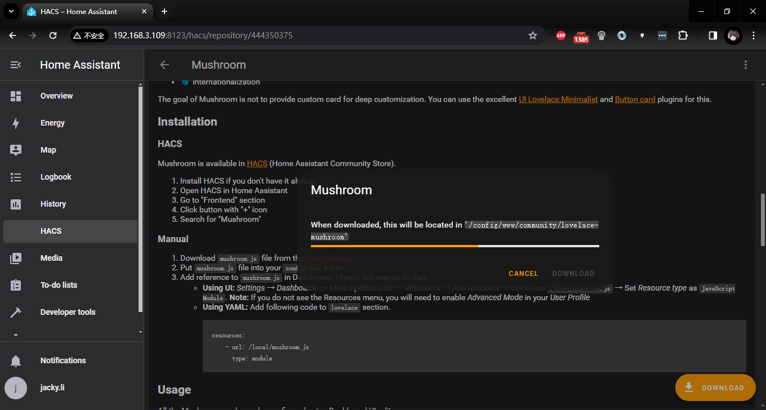

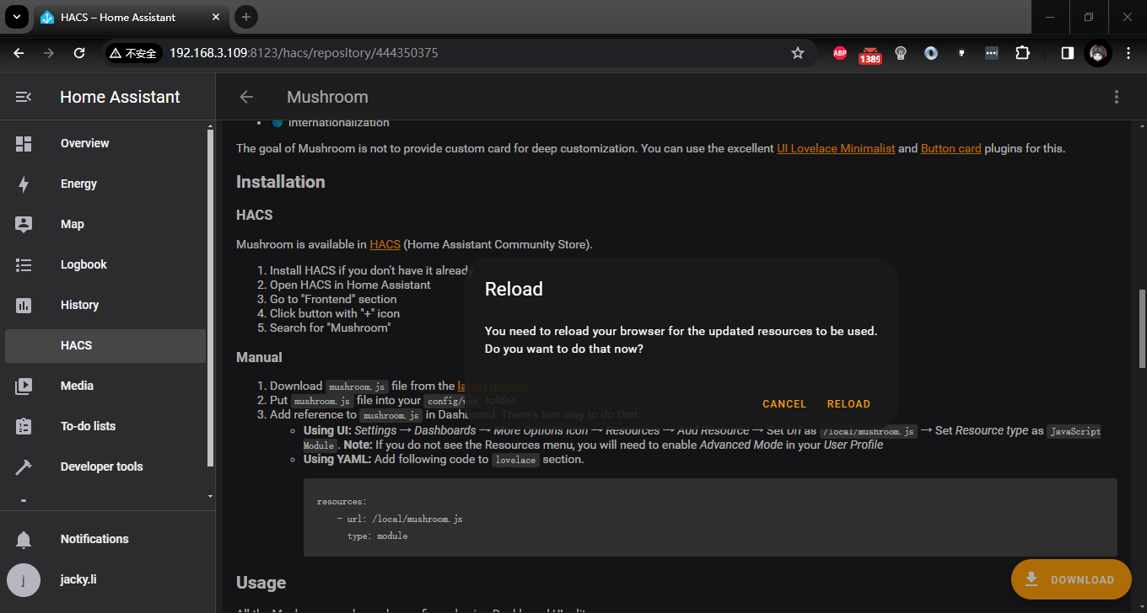

### Usage

* In Dashboard UI, click 3 dots in top right cornet.
* Click Edit Dashboard.
* Click Plus button to add a new card.
* Find one of the Custom: Mushroom card in the list.

More details please visit: <https://www.home-assistant.io/dashboards/dashboards/#creating-a-new-dashboard>

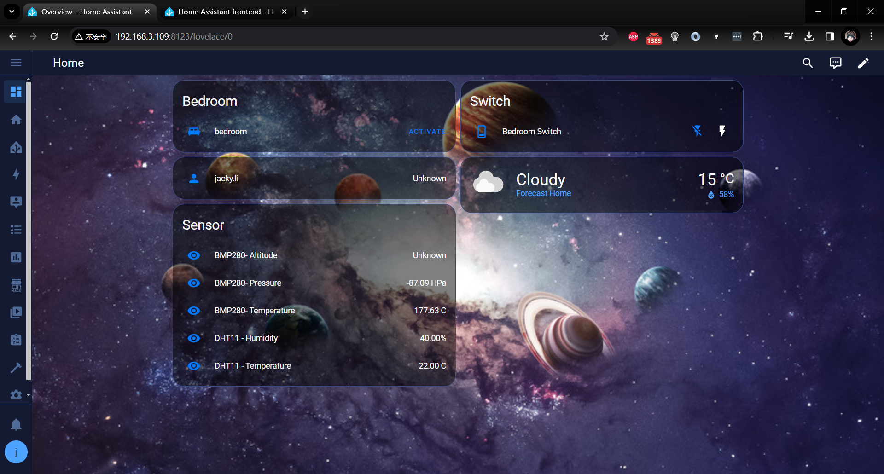

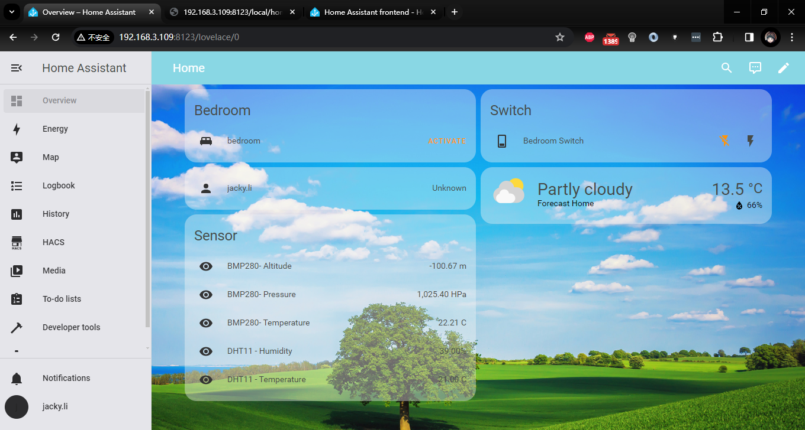

If you like minimalist style, like following figure:

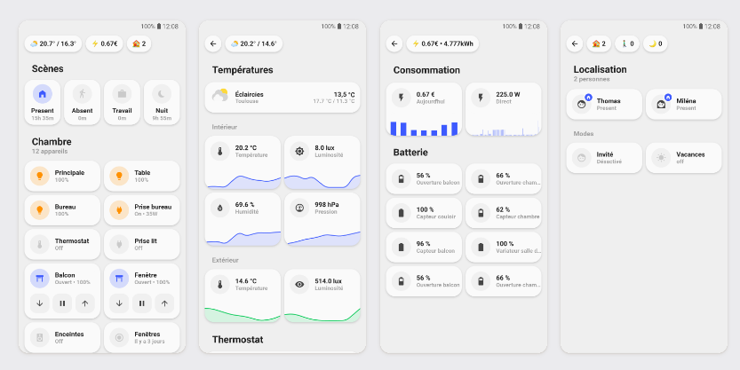

Click HACS Icon in menu and search: “UI-lovelace”, you will see following result:

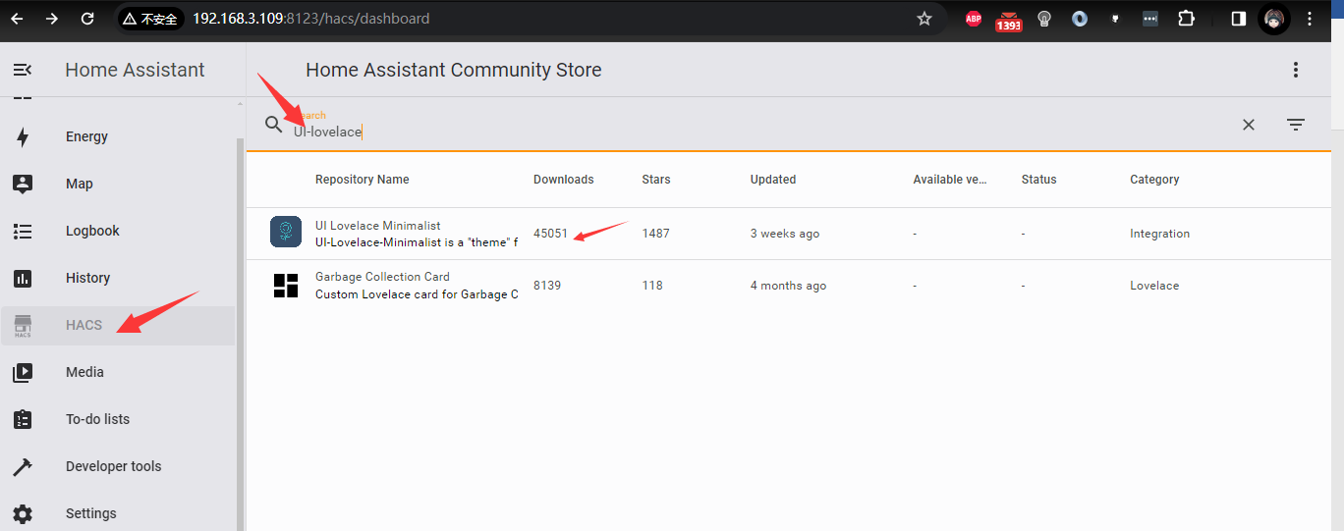

Click UI Lovelace mimialist and then click Download Icon to download this UI solution.

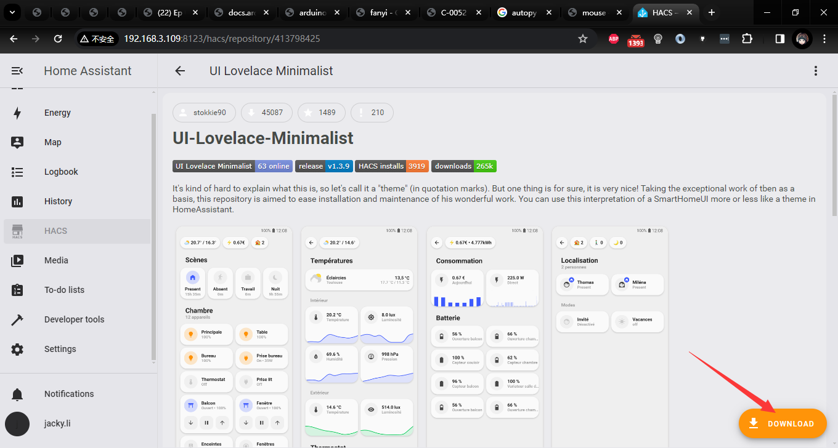

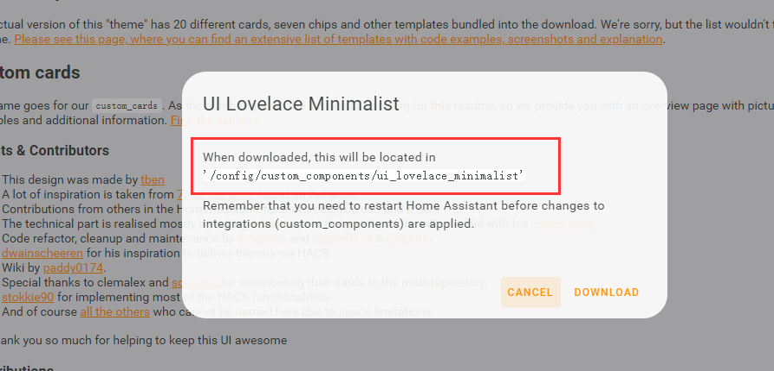

It may require restart home assistant, just do it as the tips say.

## Custom dashboard

Click Settings 🡪 Dashboards 🡪 ADD DASHBOARD

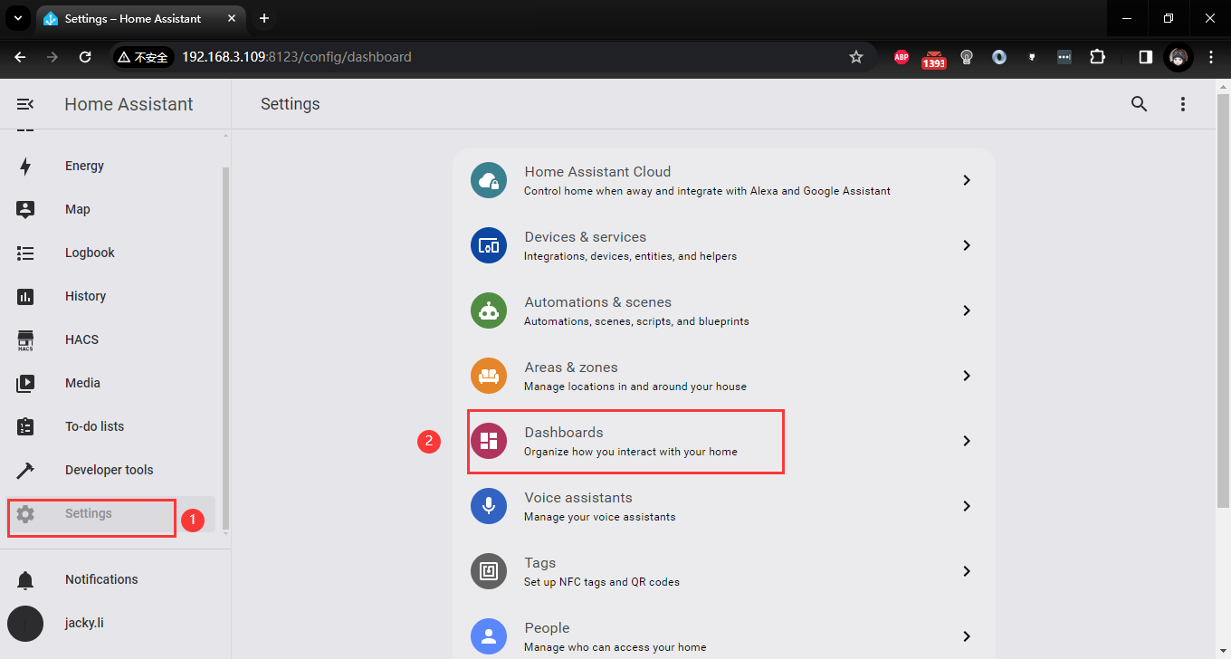

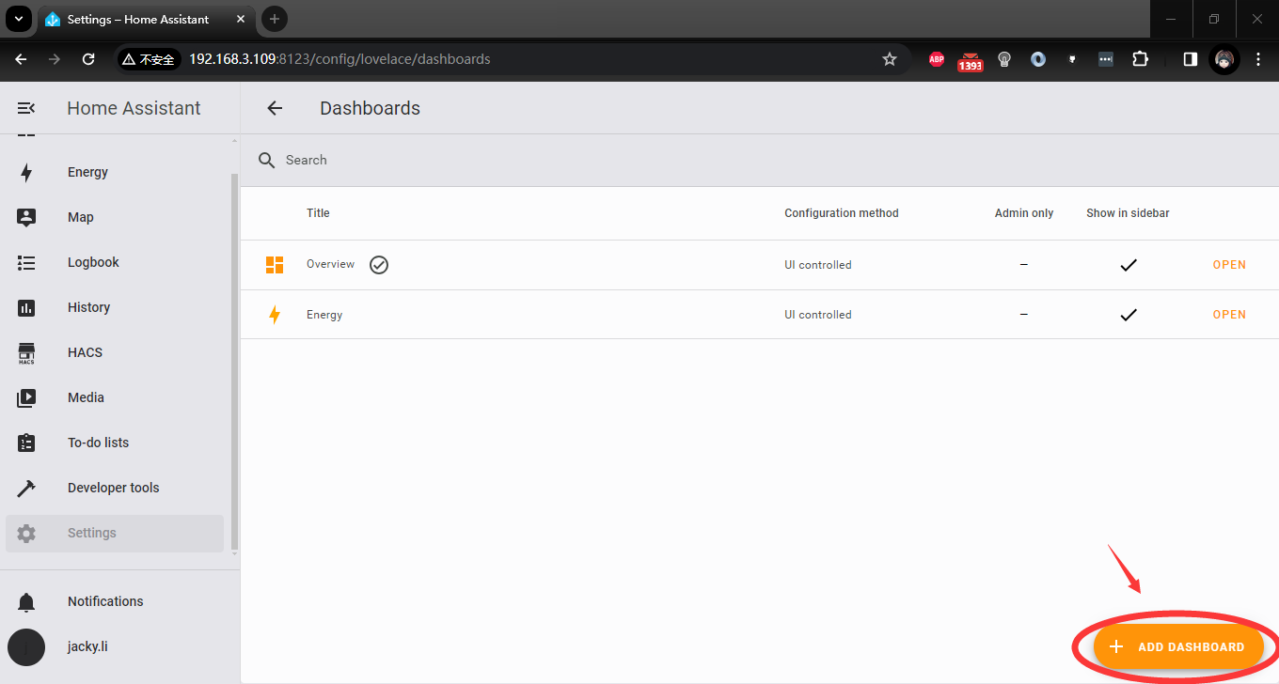

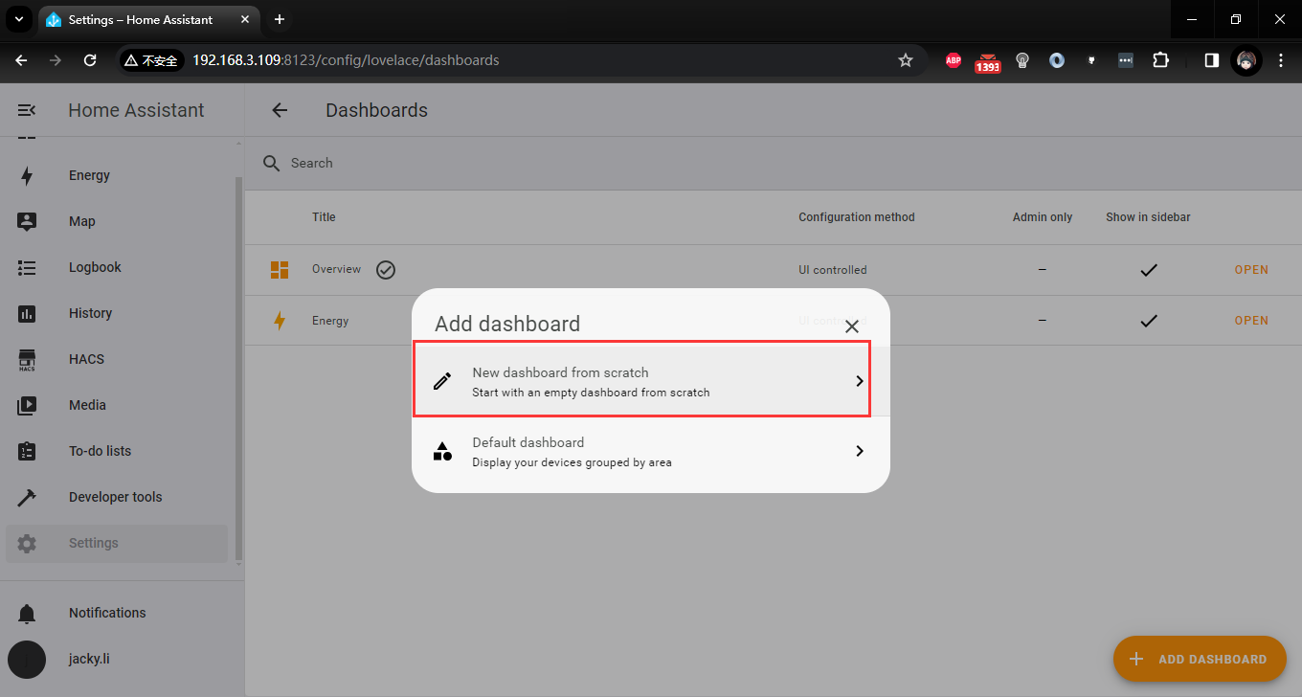

and then input title, select an icon and click create.

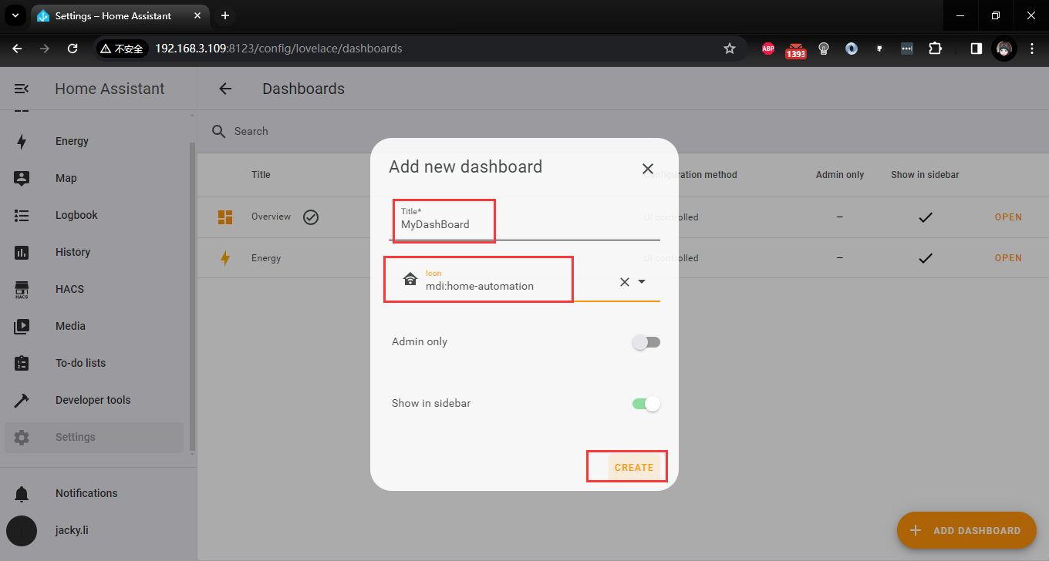

and then click “MyDashboard”

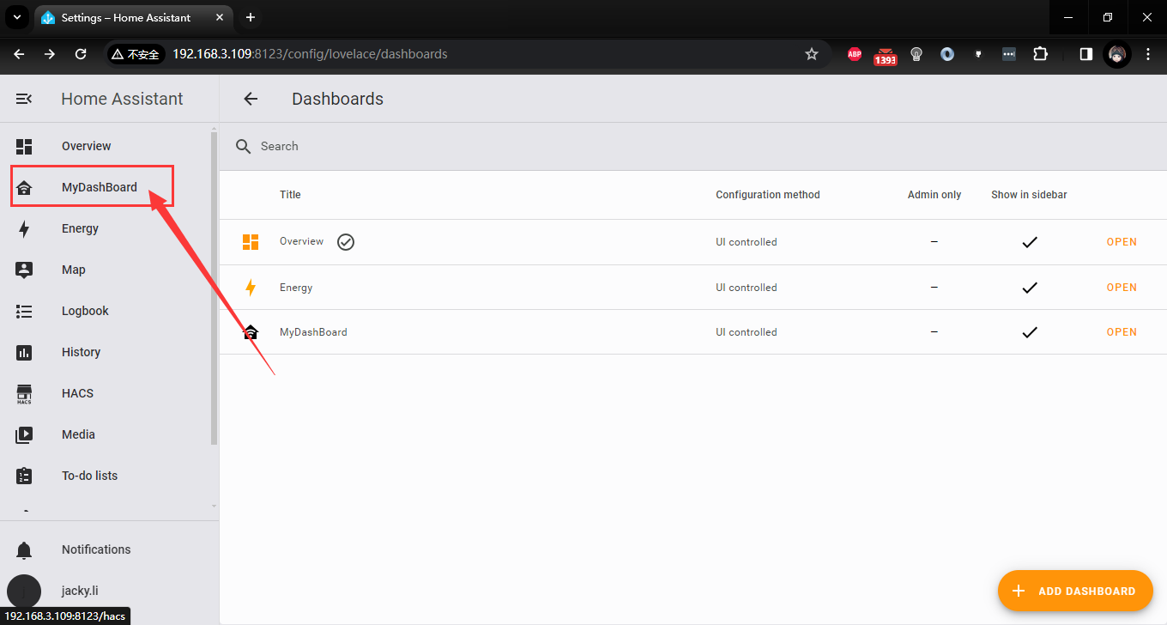

you will see an empty page like:

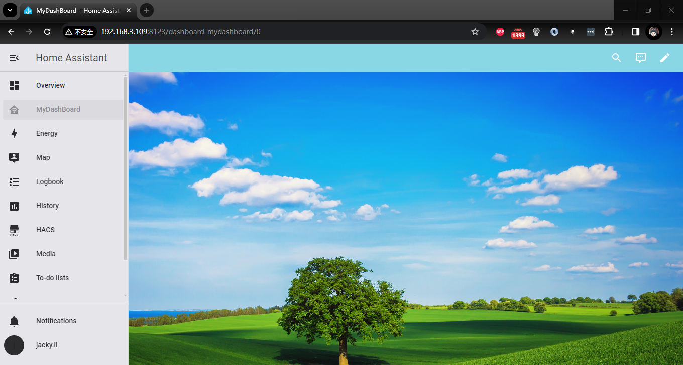

Next we need to adding some cards to filling this page.

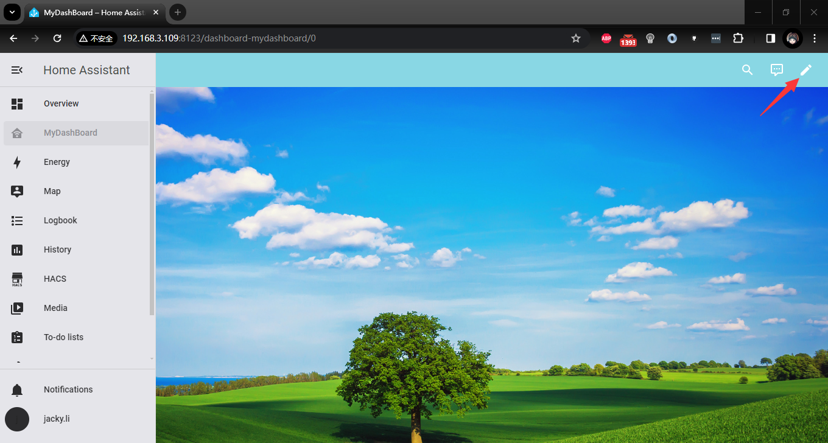

Click “+ ADD CARD”

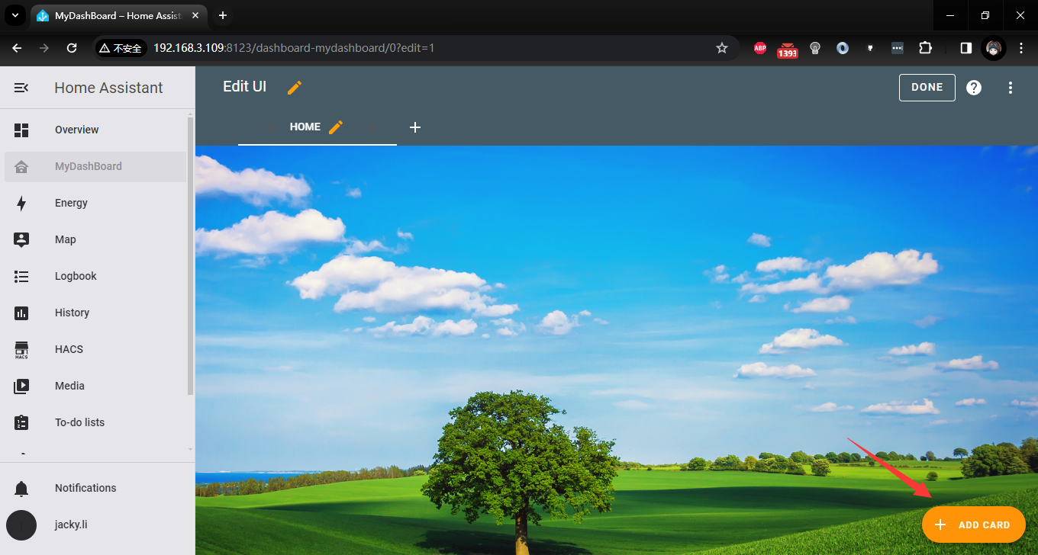

select one card by card or by ENTITY.

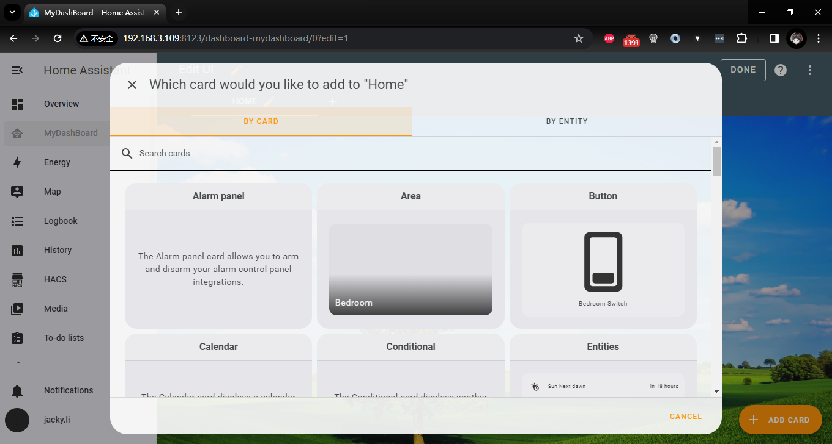

scroll down you can choose a plenty of card that it supported. for example, I want to add a card show gauge of the temperature which is gathering from arduino UNO R4. Just select Gauge card as following figure.

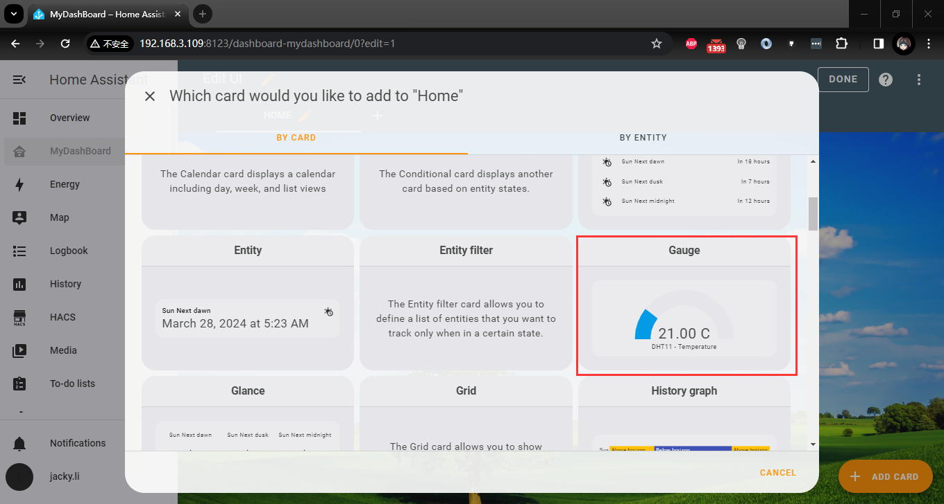

Select the entity and filling the name, unit and so on. you will preview the result at right cornor.

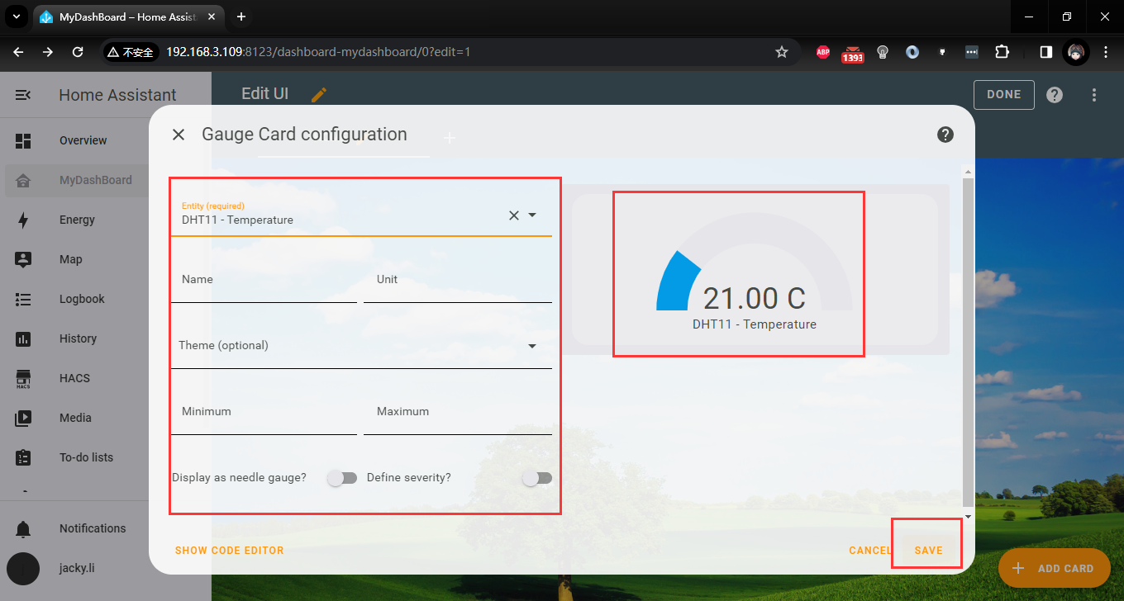

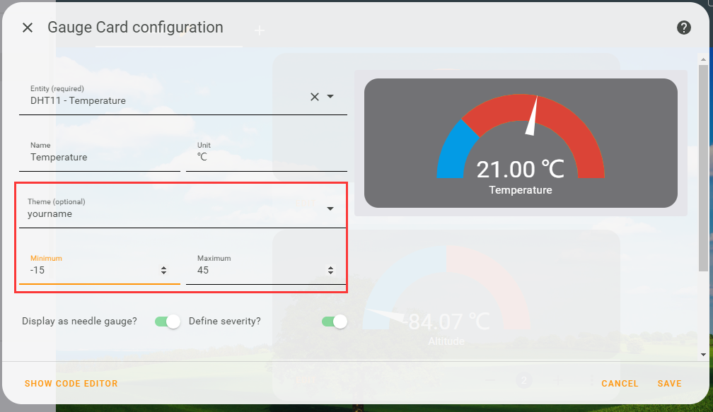

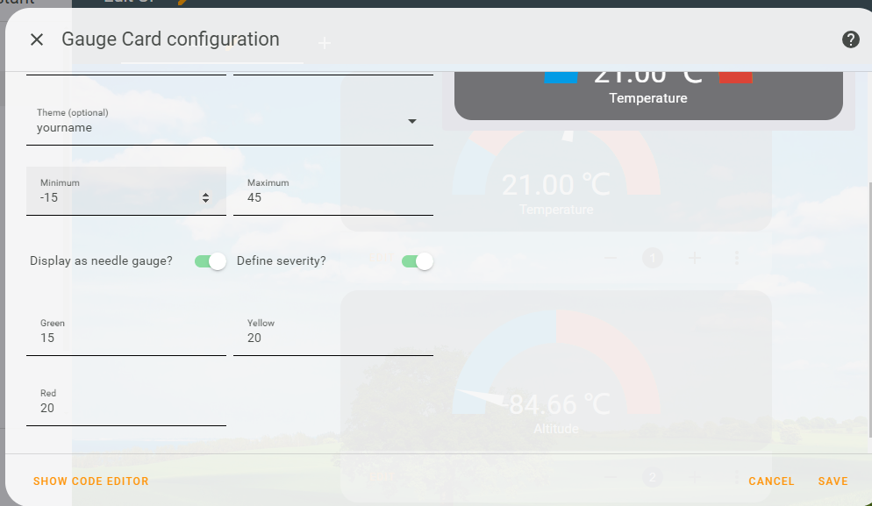

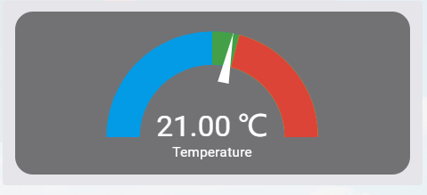

and then you can just duplicate this card and modify the parameters to adding more cards.

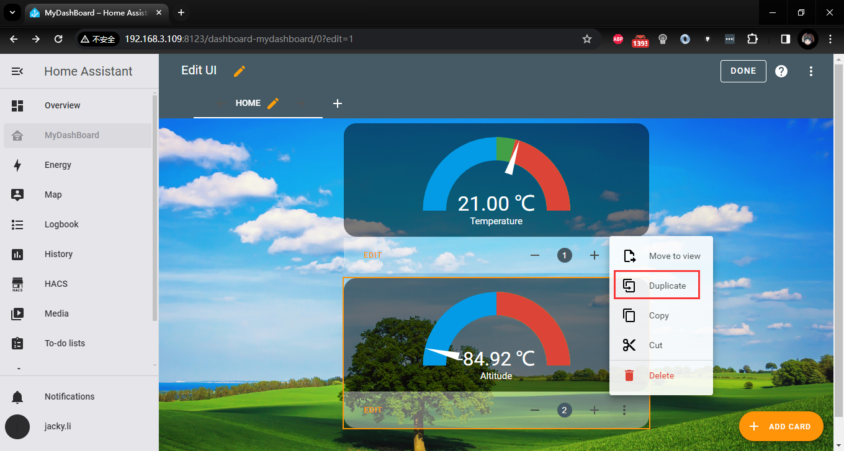

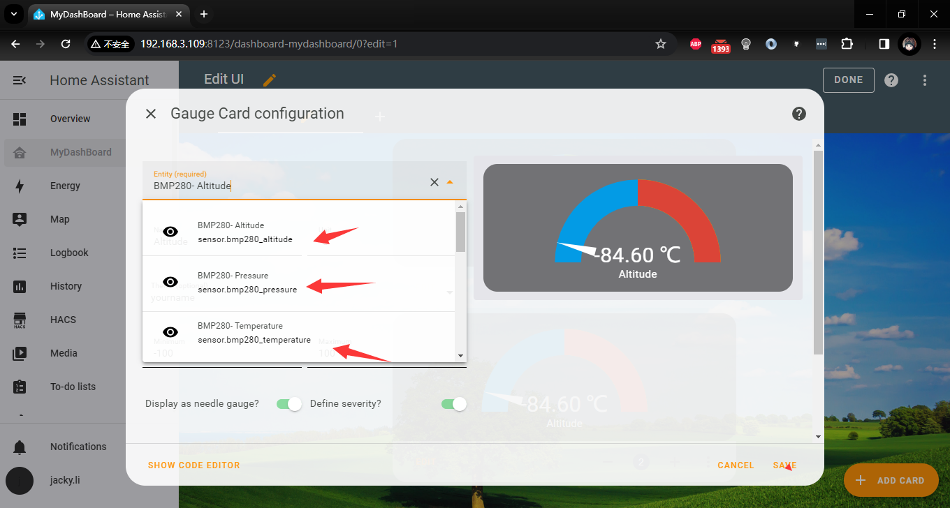

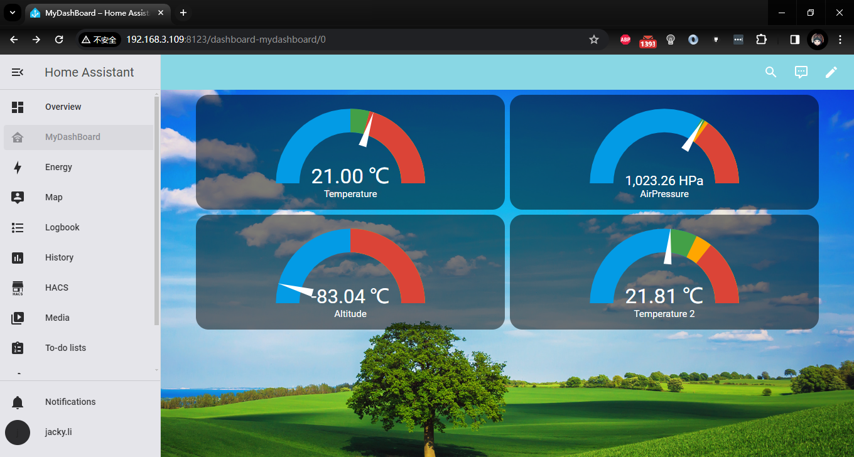

also you can add other card like a chart. 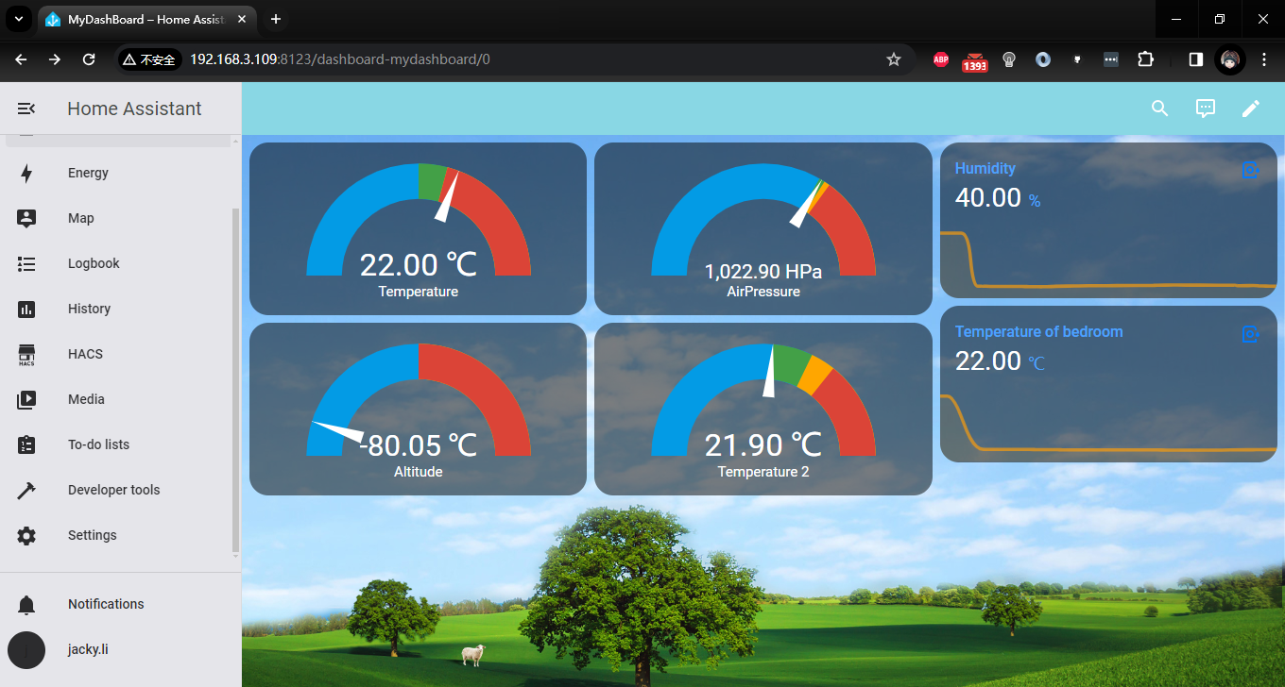

You can add more configurations for other sensors in a similar way.

## How to control the servo through the buttons on the Home Assistant page?

In the previous experiment, we collected the data information of the temperature and humidity sensor and barometer through arduino UNO R4, and uploaded it to the home assistant for display through the MQTT protocol. Below we will introduce how to add a simple button through the Home Assistant control center through a simple experiment. control to send control signals to the servo connected to arduino UNO R4 to simulate the remote control function in a smart home. The goal that needs to be achieved is that when the button is turned on and the arduino UNO R4 receives the signal, it rotates a specific angle. When the button is turned off, the servo arm returns to its original position.

### Wiring Diagram:

Please connect a servo to Arduino UNO R4 Wi-Fi board according to following chart:

|  |  |
| --- | --- |
| Arduino UNO R4 Wi-Fi board | Servo |
| 5V | Red wire |
| GND | Brown wire |
| Pin 3 | Yellow wire |

### Programming

You can open the previous sketch file through arduino IDE or rewrite a new sketch. Let's go through the setup step by step.

#### Install library

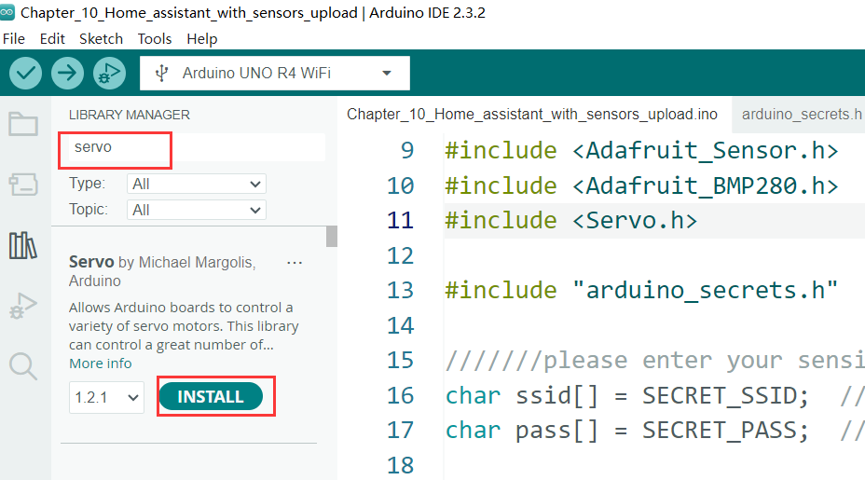

* Modify sketch content and adding Servo control part code.

#include <Servo.h>

#define servopin 3   // Pin 3 to servo signal pin

Servo myservo;  // create servo object to control a servo

int pos = 0;    // variable to store the servo position

* Define Variables to store topic information

const char topic6[] = "home/bedroom/switch1/set";

const char topic7[] = "home/bedroom/switch2/set";

* Modify setup() function：

void setup() {

  myservo.attach(servopin);

myservo.write(pos); // init to start position.

attaches the servo on pin 3 to the servo object

* Send online message back to Home assistant

  mqttClient.beginMessage("home/bedroom/switch1/available");

  mqttClient.print("online");

  mqttClient.endMessage();

  mqttClient.beginMessage("home/bedroom/switch2/available");

  mqttClient.print("online");

  mqttClient.endMessage();

* Setting mqttClient onMessage behavior

  mqttClient.onMessage(onMqttMessage);

  mqttClient.subscribe("home/bedroom/switch1/set");

  mqttClient.subscribe("home/bedroom/switch2/set");

#### Create a callback function

Create a function to handle the ON or OFF message sent from the Home assistant button to control the servo to rotate to the corresponding angle.

 void onMqttMessage(int messageSize) {

  char command[3];

  int i = 0;

  if (mqttClient.messageTopic().equals("home/bedroom/switch1/set")) {

    while (mqttClient.available()) {

      command[i++] = (char)mqttClient.read();

    }

    if (command[0] == 'O' && command[1] == 'N') {

      Serial.println("Buzzer on");

      digitalWrite(buzzer, HIGH);

      drawText(" Buzzer ON!  ");

    } else if (command[0] == 'O' && command[1] == 'F' && command[2] == 'F') {

      Serial.println("Buzzer off");

      digitalWrite(buzzer, LOW);

      drawText(" Buzzer OFF!  ");

    }

  }

  if (mqttClient.messageTopic().equals("home/bedroom/switch2/set")) {

    while (mqttClient.available()) {

      command[i++] = (char)mqttClient.read();

    }

    if (command[0] == '0' && command[1] == 'A') {

      Serial.println("Servo ON");

      myservo.write(90);

      drawText("  Servo ON!  ");

    } else if (command[0] == '1' && command[1] == 'F' && command[2] == 'F') {

      Serial.println("Servo OFF");

      myservo.write(0);

      drawText(" Servo OFF!  ");

    }

  }

#### Explanation:

Check if the message Topic equals to “home/bedroom/switch2/set” and then check if the message is ON, if the message is “0A”，print “on servo” on serial monitor and then turn servo to 90 degrees and draw text “ON!” on LED matrix. otherwise, print “off servo” on serial monitor and turn servo back to 0 degree and draw text “OFF!” on LED matrix.

#### Demo code

#include <ArduinoMqttClient.h>

#include <WiFiS3.h>

#include "ArduinoGraphics.h"

#include "Arduino_LED_Matrix.h"

#include <string.h>

#include <stdlib.h>

#include <DHT11.h>

#include <Wire.h>

#include <Adafruit_Sensor.h>

#include <Adafruit_BMP280.h>

#include <Servo.h>

#include "arduino_secrets.h"

///////please enter your sensitive data in the Secret tab/arduino_secrets.h

char ssid[] = SECRET_SSID;  // your network SSID (name)

char pass[] = SECRET_PASS;  // your network password (use for WPA, or use as key for WEP)

ArduinoLEDMatrix matrix;  // create an instance for led matrix.

// create an instance of BMP280 sensor, it will create an object called bmp280

#define BMP280_I2C_ADDRESS 0x76

Adafruit_BMP280 bmp280;

#define DHT11PIN 7      //DHT 11 sensor

DHT11 dht11(DHT11PIN);  // create an instance of dht11

#define servopin 3   // Pin 3 to servo signal pin

Servo myservo;  // create servo object to control a servo

int pos = 0; // variable to store the servo position

// bitmap frame buffer.

byte frame[8][12] = {

  { 0, 0, 1, 1, 0, 0, 0, 1, 1, 0, 0, 0 },

  { 0, 1, 0, 0, 1, 0, 1, 0, 0, 1, 0, 0 },

  { 0, 1, 0, 0, 0, 1, 0, 0, 0, 1, 0, 0 },

  { 0, 0, 1, 0, 0, 0, 0, 0, 1, 0, 0, 0 },

  { 0, 0, 0, 1, 0, 0, 0, 1, 0, 0, 0, 0 },

  { 0, 0, 0, 0, 1, 0, 1, 0, 0, 0, 0, 0 },

  { 0, 0, 0, 0, 0, 1, 0, 0, 0, 0, 0, 0 },

  { 0, 0, 0, 0, 0, 0, 0, 0, 0, 0, 0, 0 }

};

WiFiClient wifiClient;

MqttClient mqttClient(wifiClient);

const char broker[] = "192.168.3.109";

int port = 1883;

const char topic1[] = "uno/temp_in1";

const char topic2[] = "uno/humidity";

const char topic3[] = "uno/temp_in2";

const char topic4[] = "uno/pressure";

const char topic5[] = "uno/altitude";

const char topic6[] = "home/bedroom/switch1/set";

const char topic7[] = "home/bedroom/switch2/set";

// define buzzer pin

const int buzzer = 9;

// LED matrix drawText function

void drawText(const char text[]) {

  matrix.beginDraw();

  matrix.stroke(0xFFFFFFFF);

  matrix.textScrollSpeed(50);

  // add the text

  matrix.textFont(Font_5x7);

  matrix.beginText(0, 1, 0xFFFFFF);

  matrix.println(text);

  matrix.endText(SCROLL_LEFT);

  matrix.endDraw();

}

void setup() {

  myservo.attach(servopin);  // attaches the servo on pin 3 to the servo object

  myservo.write(pos);

  pinMode(buzzer, OUTPUT);

  digitalWrite(buzzer, LOW);  // turn off buzzer

  // init matrix and setting renderbitmap.

  matrix.begin();

  matrix.renderBitmap(frame, 8, 12);

  // init bmp280

  if (!bmp280.begin(BMP280_I2C_ADDRESS)){

    Serial.println("Could not find a valid BMP280 sensor, check wiring!!!");

    while(1);

  }

  // init serial port

  Serial.begin(9600);

  while (!Serial) {

    ;  // wait for serial port to connect. Needed for native USB port only

  }

  // attempt to connect to WiFi network:

  Serial.print("Attempting to connect to WPA SSID: ");

  Serial.println(ssid);

  while (WiFi.begin(ssid, pass) != WL_CONNECTED) {

    // failed, retry

    Serial.print(".");

    delay(5000);

  }

  Serial.print("IP address:");

  Serial.println(WiFi.localIP());

  Serial.println("You're connected to the network");

  Serial.println();

  // You can provide a unique client ID, if not set the library uses Arduino-millis()

  // Each client must have a unique client ID

  mqttClient.setId("uno_R4_01");

  // You can provide a username and password for authentication

  mqttClient.setUsernamePassword("jacky", "mypassword");

  Serial.print("Attempting to connect to the MQTT broker: ");

  Serial.println(broker);

  if (!mqttClient.connect(broker, port)) {

    Serial.print("MQTT connection failed! Error code = ");

    Serial.println(mqttClient.connectError());

    while (1) {

      if (!mqttClient.connect(broker, port)) {

        Serial.print("MQTT connection failed! Error code = ");

        Serial.println(mqttClient.connectError());

      }

    }

  }

  Serial.println("You're connected to the MQTT broker!");

  Serial.println();

  Serial.println("Sending available to topic!");

  // send message, the Print interface can be used to set the message contents

  mqttClient.beginMessage("home/bedroom/switch1/available");

  mqttClient.print("online");

  mqttClient.endMessage();

  mqttClient.beginMessage("home/bedroom/switch2/available");

  mqttClient.print("online");

  mqttClient.endMessage();

  Serial.println();

  mqttClient.onMessage(onMqttMessage);

  mqttClient.subscribe("home/bedroom/switch1/set");

  mqttClient.subscribe("home/bedroom/switch2/set");

}

void onMqttMessage(int messageSize) {

  char command[3];

  int i = 0;

  if (mqttClient.messageTopic().equals("home/bedroom/switch1/set")) {

    while (mqttClient.available()) {

      command[i++] = (char)mqttClient.read();

    }

    if (command[0] == 'O' && command[1] == 'N') {

      Serial.println("Buzzer on");

      digitalWrite(buzzer, HIGH);

      drawText(" Buzzer ON!  ");

    } else if (command[0] == 'O' && command[1] == 'F' && command[2] == 'F') {

      Serial.println("Buzzer off");

      digitalWrite(buzzer, LOW);

      drawText(" Buzzer OFF!  ");

    }

  }

  if (mqttClient.messageTopic().equals("home/bedroom/switch2/set")) {

    while (mqttClient.available()) {

      command[i++] = (char)mqttClient.read();

    }

    if (command[0] == '0' && command[1] == 'A') {

      Serial.println("Servo ON");

      myservo.write(90);

      drawText("  Servo ON!  ");

    } else if (command[0] == '1' && command[1] == 'F' && command[2] == 'F') {

      Serial.println("Servo OFF");

      myservo.write(0);

      drawText(" Servo OFF!  ");

    }

  }

}

int delay_cnt = 0;

void loop() {

  // call poll() regularly to allow the library to send MQTT keep alives which

  // avoids being disconnected by the broker

  mqttClient.poll();

  delay(1);

  delay_cnt++;

  if (delay_cnt == 100) {

    // read data from DHT11 sensor

    float humidity = dht11.readHumidity();

    float temperature = dht11.readTemperature();

    Serial.print(temperature);

    Serial.print("\t");

    Serial.print(humidity);

    Serial.print("\t");

    mqttClient.beginMessage(topic1);

    mqttClient.print(temperature);

    mqttClient.endMessage();

    mqttClient.beginMessage(topic2);

    mqttClient.print(humidity);

    mqttClient.endMessage();

  } else if (delay_cnt == 200) {

    // read temperature, pressure and altitude from BMP280 sensor

    float bmp_temp = bmp280.readTemperature();                    //

    float bmp_pressure = bmp280.readPressure() / 100.0;         //Read Pressure in Pa and conversion to inches of mercury;

    float bmp_altitude = bmp280.readAltitude(1013.25);  //Calculating the Altitude, the "1013.25"  is the pressure in(hPa) at sea level at day in your region

    Serial.print(bmp_temp);

    Serial.print("\t");

    Serial.print(bmp_pressure);

    Serial.print("\t");

    Serial.print(bmp_altitude);

    Serial.print("\t\t");

    mqttClient.beginMessage(topic3);

    mqttClient.print(bmp_temp);

    mqttClient.endMessage();

    mqttClient.beginMessage(topic4);

    mqttClient.print(bmp_pressure);

    mqttClient.endMessage();

    mqttClient.beginMessage(topic5);

    mqttClient.print(bmp_altitude);

    mqttClient.endMessage();

  } else if (delay_cnt == 500) {

    delay_cnt = 0;

  }

}

##### Compile & upload sketch

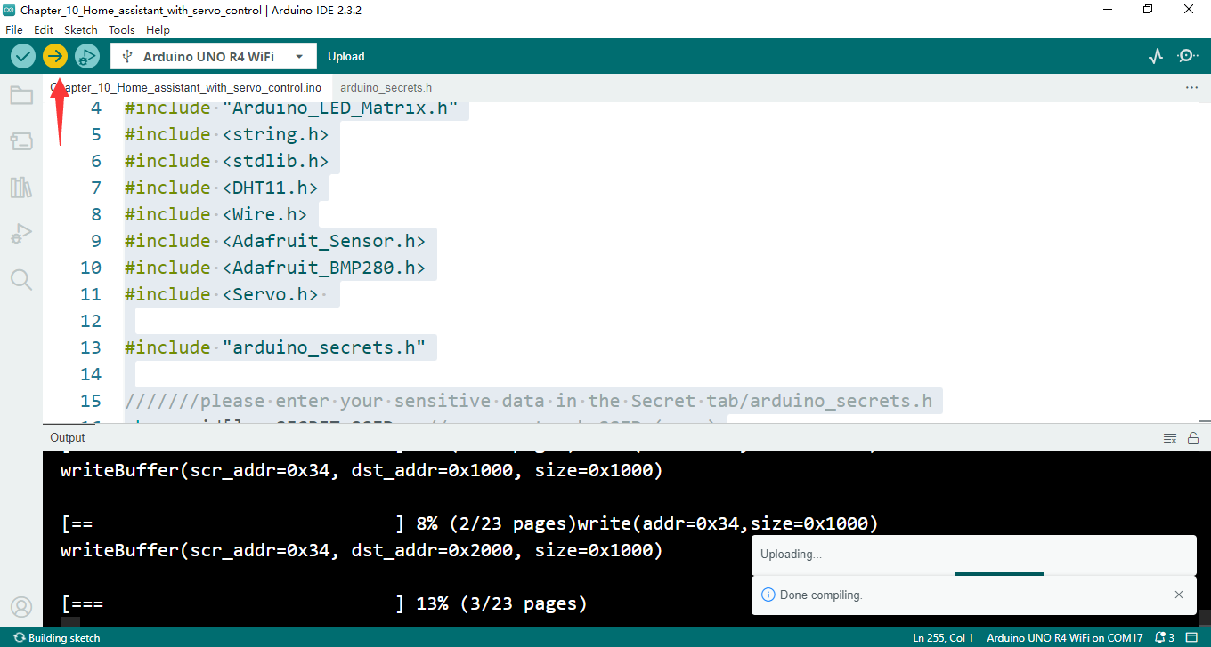

#### Modify Configuration.yaml on Raspberry Pi

We need to modify the configuration.yaml file on the home assistant server side and add a switch object. The yaml configuration content is as shown in the figure below:

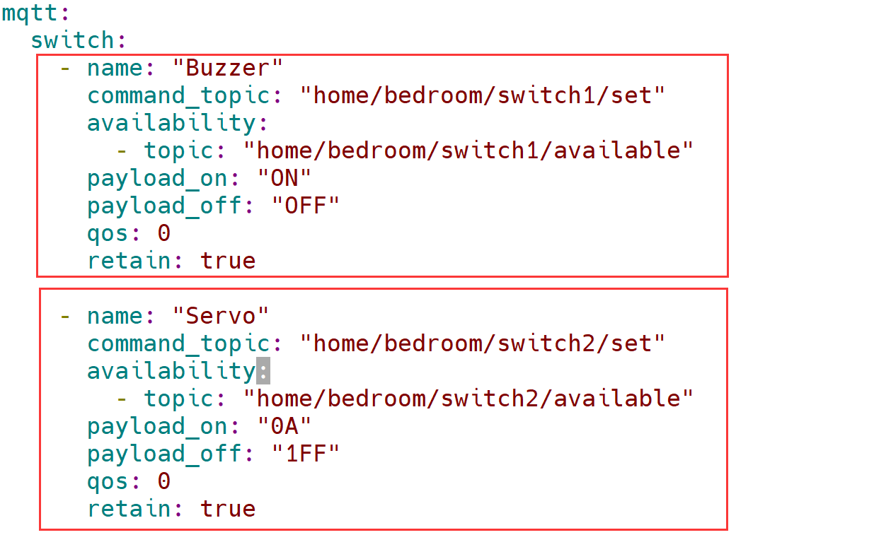

##### Restart Home Assistant

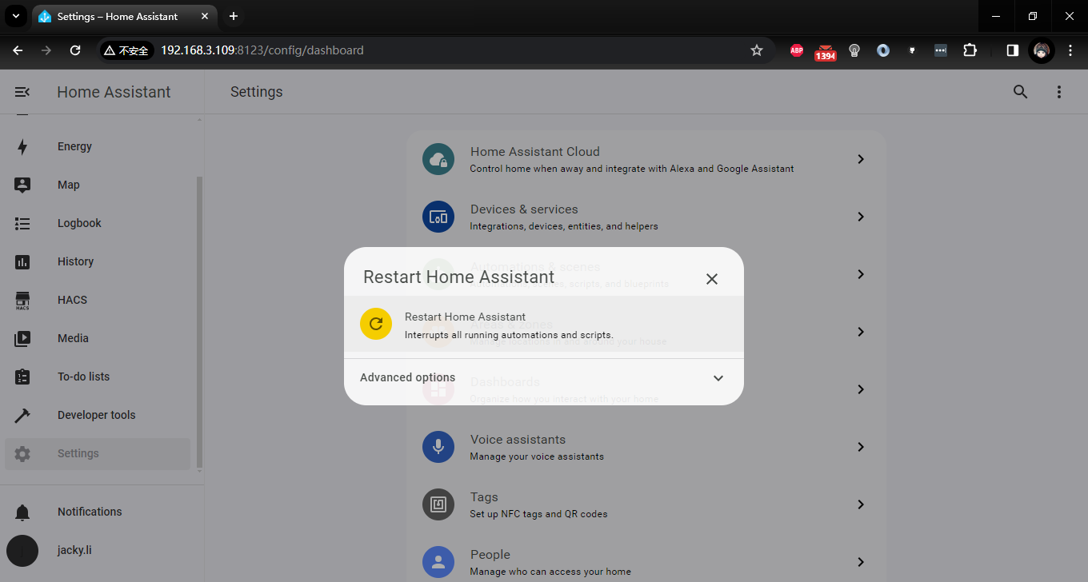

###### Edit dashboard

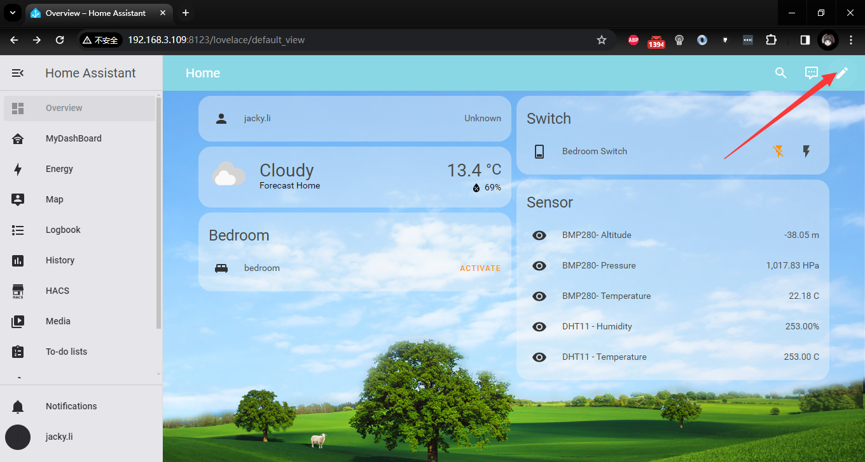

###### Add Cards

Click add card



and then select button

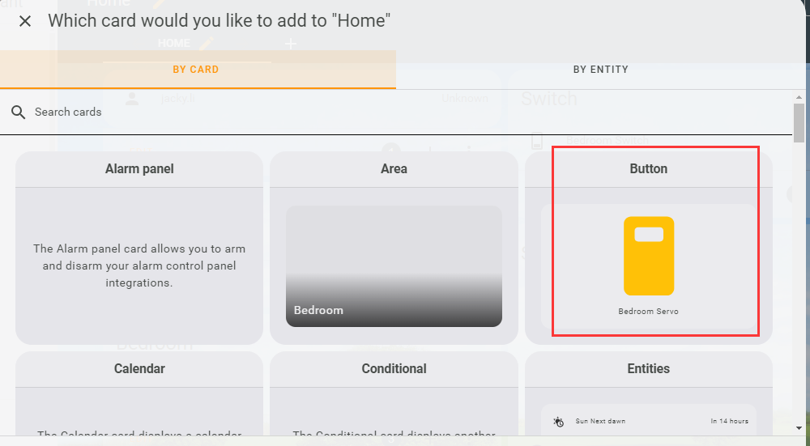

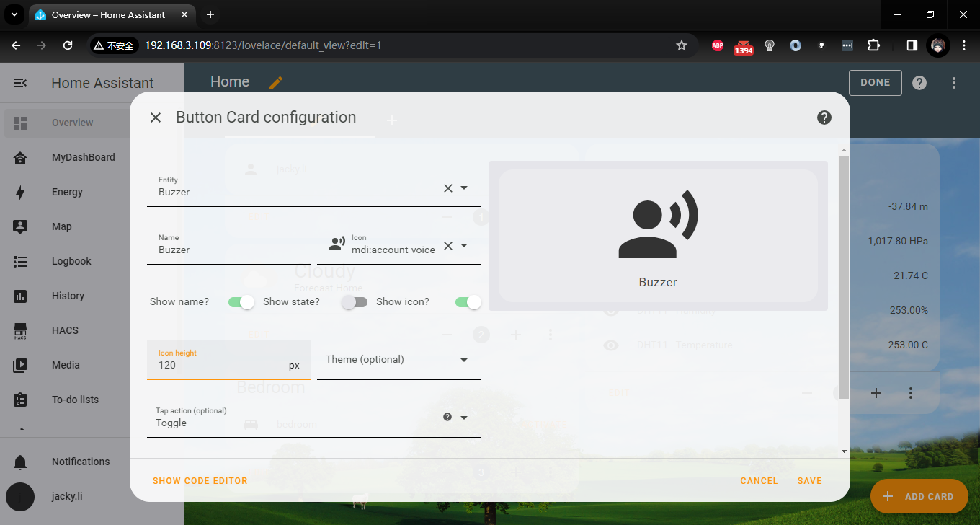

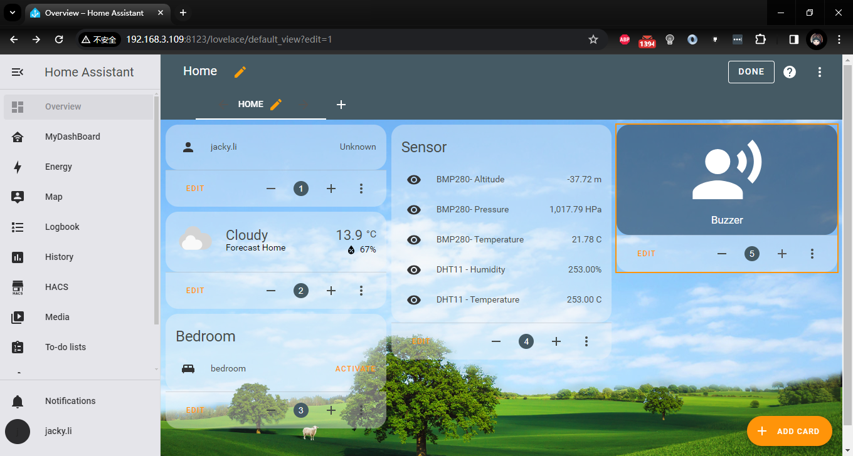

Click ADD CARD again and select the Entity: Servo

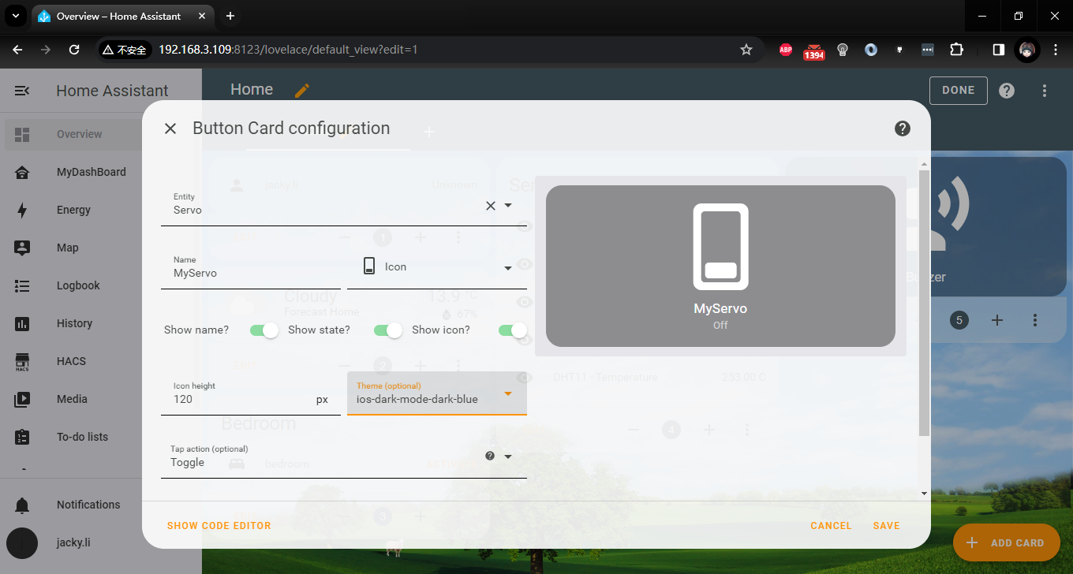

After that, you can modify layout by change the number of card.

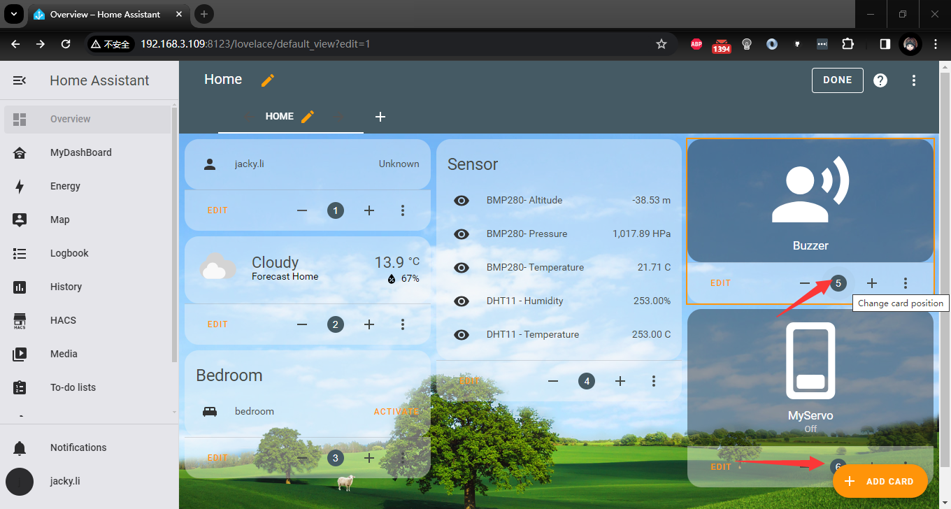

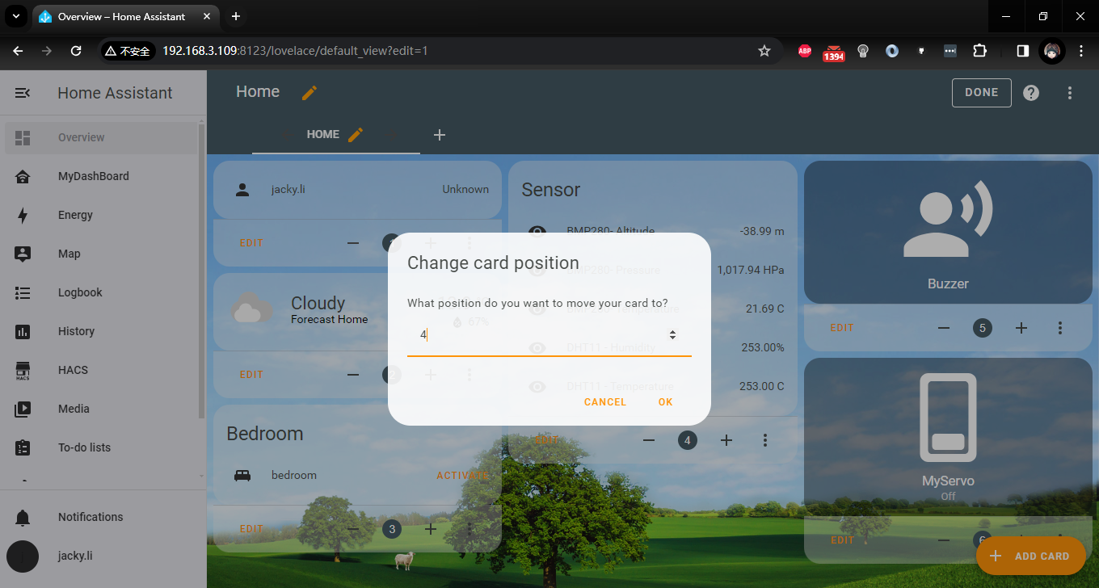

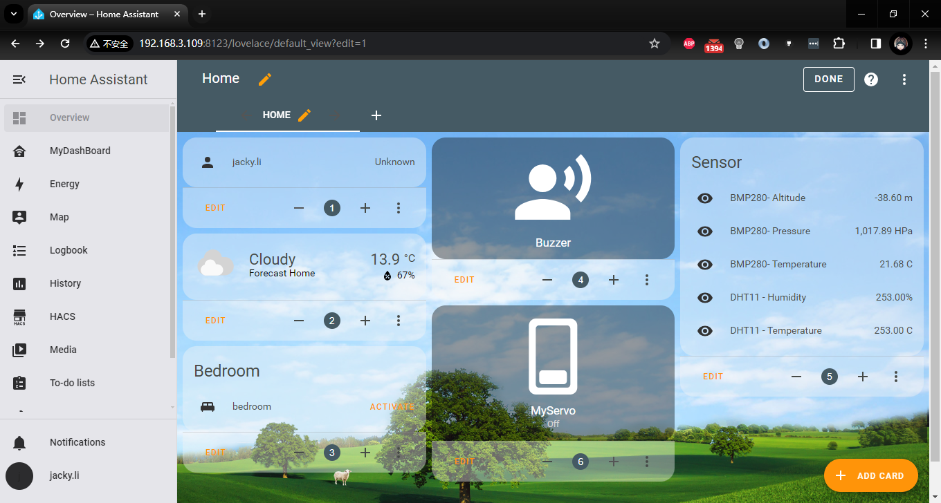

Then click “DONE” to quit to overview.

But we found that the themes of these cards are not very coordinated. If I want to unify the tone, I can unify the style by modifying the theme attribute of each card.

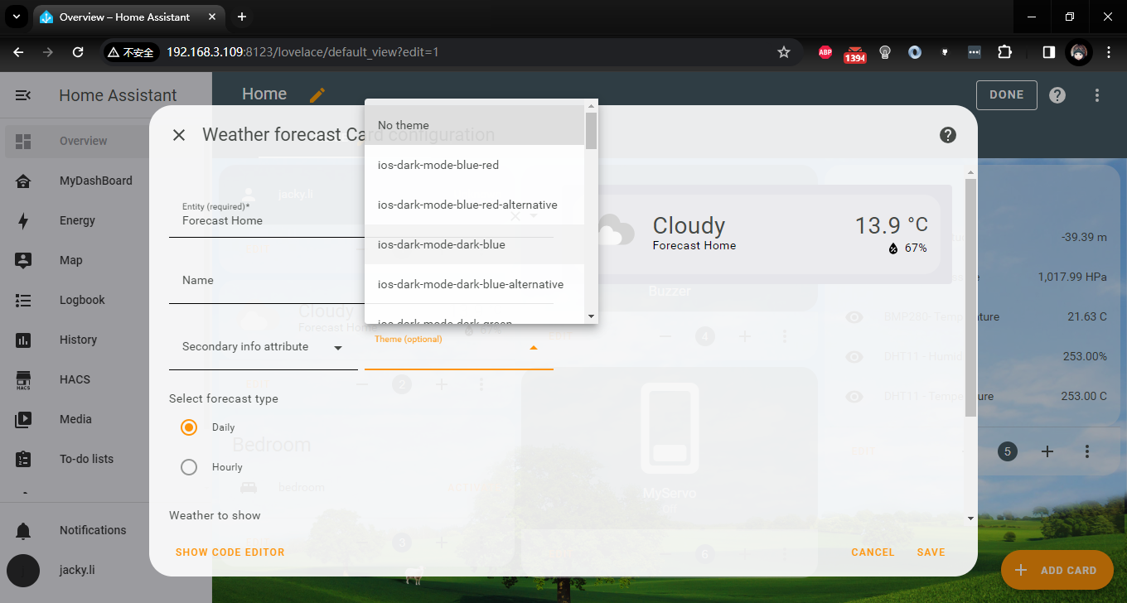

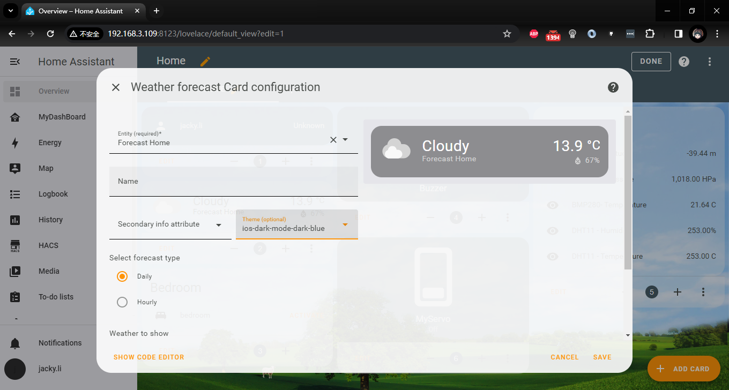

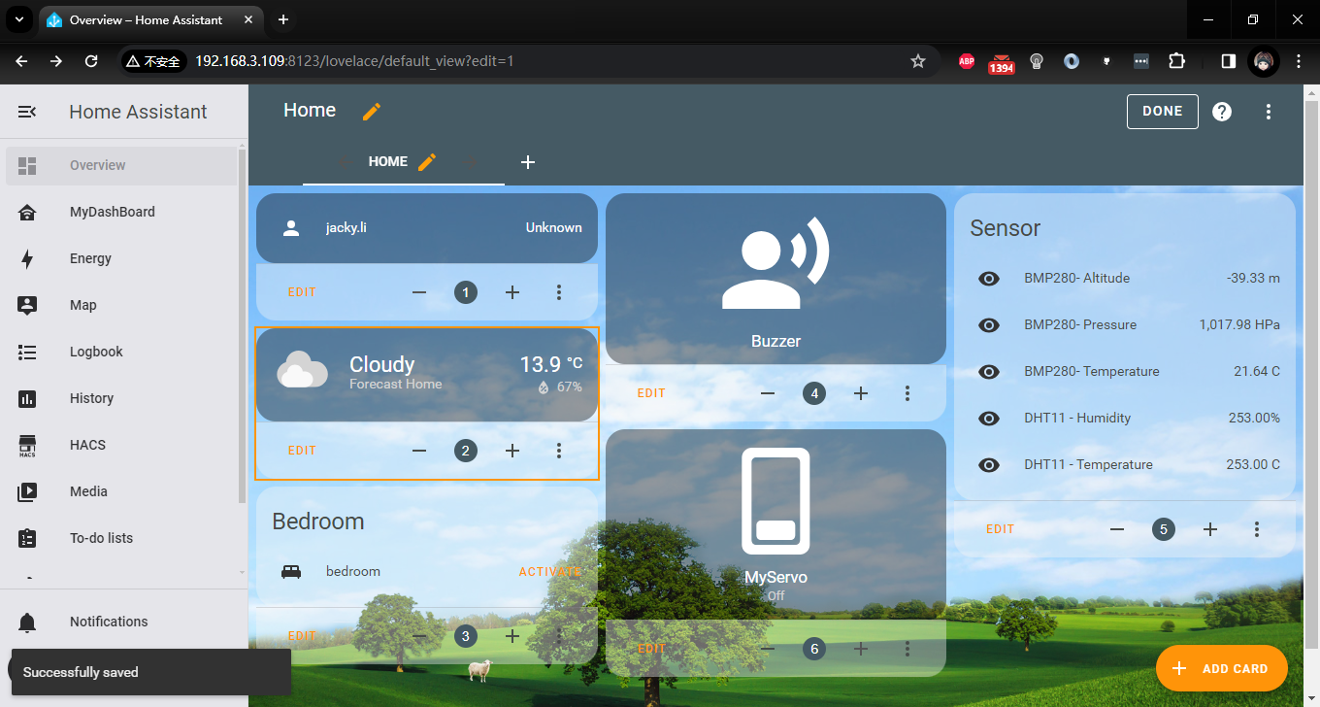

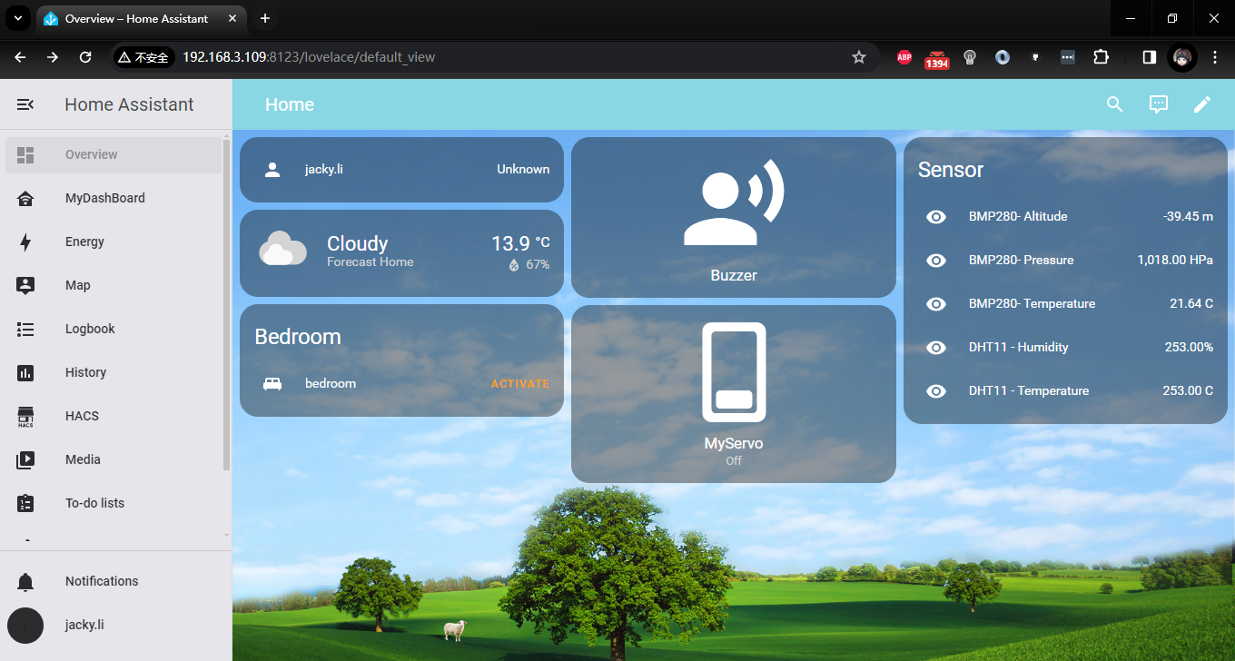

Doesn’t it look very iOS style?

##### Access Home Assistant from Mobile Phone

Open a browser on your phone and make sure your phone can access your Raspberry Pi’s IP address, it means you need put the mobile phone and your Home assistant server at the network.

Open browser and access: <http://192.168.3.109:8123> and login with your own username and password. Please replace the IP address to your home assistant server’s IP address.

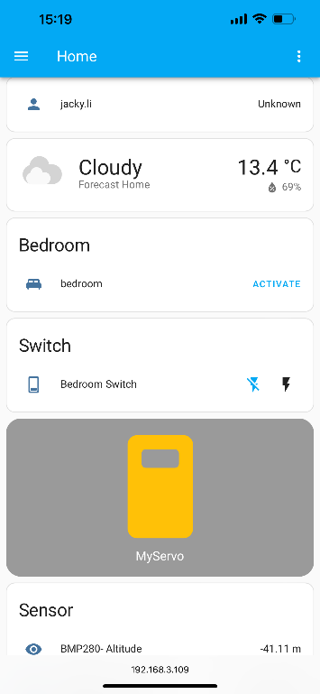 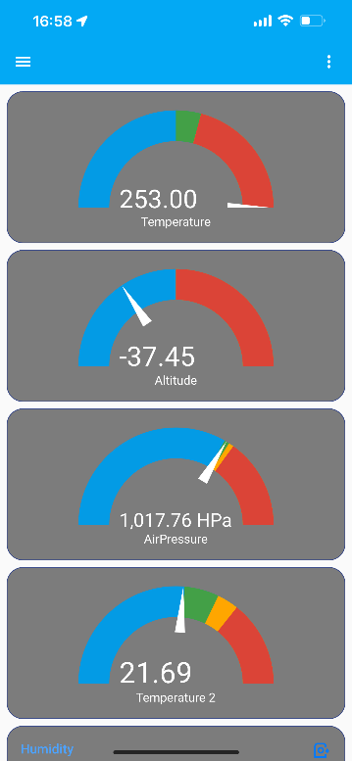

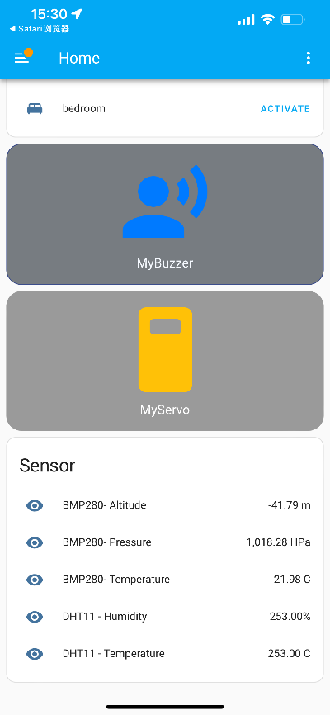 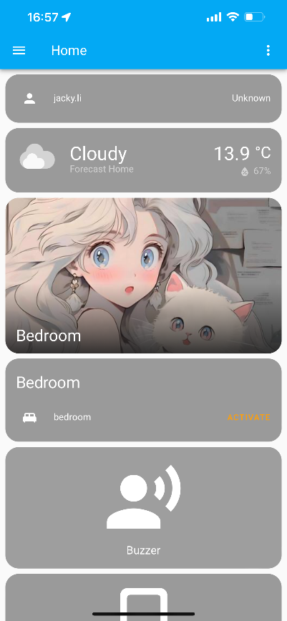

Let’s test it, just click the Switch “Servo”. If successful, the servo arm will turn to 90 degrees.

and then click it again, it will get back to 0 degree.

## Control home lighting equipment by using Relay

### Tips for Users:

#### Installation Requirements:

Have the relay system installed by a professional electrician or qualified technician.

Ensure power is disconnected and safely grounded.

Adhere to all applicable electrical safety standards and regulations.

#### Operating Guidelines:

Before operating the relay or related equipment, ensure familiarity with the operation manual and safety guidelines.

Avoid operating electrical equipment in damp or wet environments.

#### Maintenance:

Regularly inspect the relay system and related connections to ensure proper operation.

Discontinue use of any equipment showing signs of malfunction and have it serviced by a professional.

#### Usage Environment:

Ensure relays and related equipment are installed in well-ventilated, dry, and dust-free environments.

Avoid locations with high temperatures, humidity, corrosive substances, or excessive dust.

Disclaimer:

#### Installation Responsibility:

We are not liable for any personal injury or property damage resulting from user-installed or operated relay systems.

#### Usage Risks:

Users understand and accept that there are inherent risks associated with using relay systems, including but not limited to electric shock and fire hazards.

#### Improper Use:

We are not liable for any losses or damages resulting from the improper use of relay systems by users.

#### Warranty Scope:

Unless explicitly stated, we do not provide warranty coverage for relay system failures or damages caused by non-human factors.

#### Legal Limitations:

This disclaimer does not exclude or limit consumer rights protected by law.

#### Professional Advice:

Consult a qualified electrical engineer or professional when installing, operating, or maintaining relay systems.

#### Several benefits:

* **Convenient Wireless Control:**

Arduino UNO R4 Wi-Fi allows remote control via Wi-Fi, eliminating the need for additional wired connections and making control more convenient.

* **Flexibility and Scalability:**

As an open-source platform, Arduino UNO R4 Wi-Fi offers customization options, enabling users to tailor programs for various smart home functions with ease of expansion and upgrades.

* **Cost-Effective High Performance:**

Arduino UNO R4 Wi-Fi provides stable and reliable performance at a relatively low cost, particularly when combined with relay modules to control high-power devices.

* **Security and Stability:**

With robust security features such as encryption and authentication, Arduino UNO R4 Wi-Fi ensures system safety and stability, guarding against unauthorized access.

* **Programmability and Automation:**

Programmable capabilities allow for automation of smart home functions like scheduling lights, temperature control, and remote monitoring, enhancing comfort and convenience.

* **Compatibility with Other Smart Devices:**

Arduino UNO R4 Wi-Fi integrates seamlessly with other smart devices (e.g., smartphones, smart speakers), enabling interconnected smart home systems for an enhanced user experience.

In summary, leveraging Arduino UNO R4 Wi-Fi with relays for smart home control offers convenient wireless operation, flexibility for customization and expansion, cost-effectiveness, security, programmable automation, and compatibility with a variety of smart devices, thereby enhancing overall living convenience and efficiency.

**Leave yourself a hands-on segment:** try using the two-channel relay module provided in the kit, combined with your existing Home Assistant environment, to transform your household lighting management system!

 **If children are operating this experiment, they must be accompanied by an adult, have a detailed understanding of the working principles of high-voltage circuits, and take precautions against electric shock."**

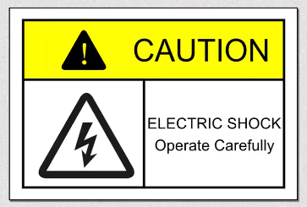

Let’s get to next chapter and enjoy new journey!!!